Community Prevention and Wellness Initiative (CPWI) Resource Guide: Writing Your Strategic Plan
A Description of Requirements and Resources to Assist Your Coalition in Strategic Plan Development and Implementation

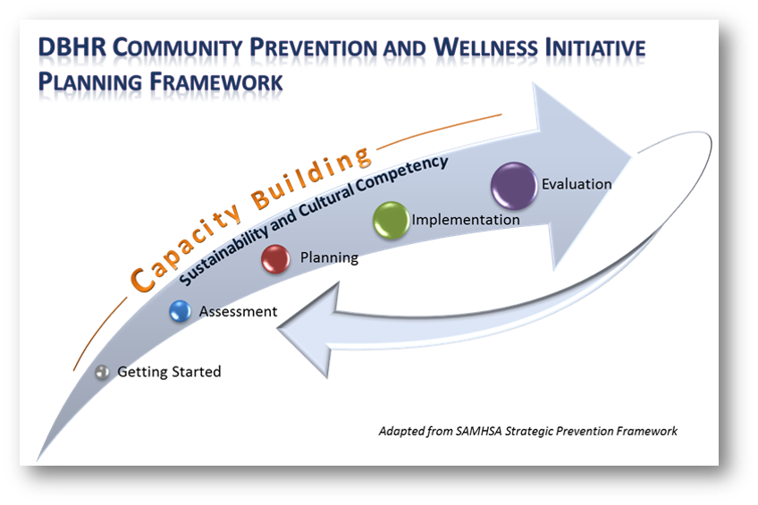

Revised October 2021

Table of Contents
Introduction to Strategic Plan Resource Guide 3
Timeline for Strategic Plan Due Dates 3
Update of Strategic Plan 3
What is a Strategic Plan? 3
CPWI Strategic Plan 3
Writing the Coalition’s Strategic Plan 4
Executive Summary/Introduction 7
Organizational Development (Getting Started) 8
Mission and Model 8
Coalition Structure and Organization 8
Membership Recruitment and Retention 8
Cultural Competency in Organizational Development 8
Sustainability in Organizational Development 9
Capacity Building 10
Outreach 10
Training/Technical Assistance (TA) 10
Cultural Competency in Capacity Building 10
Sustainability in Capacity Building 10
Sample Training Plan for Strategic Plan 11
Assessment 12
Needs Assessment 12
Resources Assessment 13
Cultural Competency in Assessment 13
Sustainability in Assessment 13
Planning 14
Process for Planning 14
Goals, Objectives, and Strategies 14
Action Plan 14
Cultural Competency in Assessment 14
Sustainability in Assessment 14
Implementation 16
Structural Support for Implementation 16
Budget 16
Cultural Competency in Implementation 16
Sustainability in Implementation 16
Reporting and Evaluation 17
Expected Outcomes 17
Plan for Tracking and Reviewing Evaluation Information 18
Cultural Competency in Evaluation 18
Sustainability in Evaluation 18
Appendices 19

Overview of the Strategic Plan, Action Plan, and Budget
The purpose of this document is to provide the CPWI requirements for completing the Coalition’s Strategic Plan, Action Plan, and Budget. It is meant to be helpful for communities and Coalitions in developing their plans on an ongoing basis. This first part is general information that applies to the overall development of your plan.

Annual Action Plan and Budget Updates
Each year by June 15th for Cohorts 1-4 and August 15th for Cohort 5-6, Coalitions submit an updated Action Plan and Budget for review and approval to their DBHR Contract Manager. This update should include changes needed to strategies, programs, and/or activities based on the Coalition’s review and discussion of evaluation information or enhanced/decreased capacity. With new Coalition cohorts on a different timeline, the annual action plan updates will be negotiated with DBHR.

Timeline for Strategic Plan Due Dates
- Action Plan and Budget is required to be updated annually by June 15th for Cohorts 1-4 and August 15th for Cohorts 1-6.
- Comprehensive Update of Strategic Plan for all Cohorts 1-6 is due June 15, 2022.
- Cohort 7 Strategic Plans are due February 11, 2022. Comprehensive Updates for Cohort 7 will be negotiated separately.

2022 Update of Strategic Plan
By June 15, 2022, all Cohort 1-6 Coalitions will submit an update of their Strategic Plan. This update should include changes to goals, objectives, strategies, programs, and/or activities based on the Coalition’s review and discussion of evaluation information, new assessment information, or enhanced/decreased capacity. Coalitions will need to do an update to their needs and resources assessment based on new HYS and other assessment data available. Coalitions will need to determine what other updates/revisions are needed in each section of their Plan to reflect changes made to Coalition functioning, goals, objectives, strategies, programs, and/or activities. Coalitions are not expected to re-write their Plans at this time. They are simply to review new information and update the Plan as needed.

What is a Strategic Plan?
The Coalition’s Strategic Plan brings together in one place the process, findings, decisions, and plan for the future for each step of the planning framework. Strategic Plans create, confirm and provide documentation of the intended vision and goals of a Coalition. A Strategic Plan should set the course for the work of the Coalition with a long-term focus while also maintaining the immediate work that needs to be completed. Strategic Plans should be “living documents” that provide direction but also are updated regularly to account for assessment and evaluation information.

CPWI Strategic Plan
The Coalition should follow the guidance set forth in this document to develop and write their Strategic Plan.
The Coalition’s Strategic Plan should be for your community. We encourage Coalitions to consider including all of the Coalition efforts in the Plan; however, the Coalition is only required to submit a Plan for the Coalition’s CPWI activities. The Coalition may choose to do it either way, but you should note your choice in the beginning of the Plan and follow that choice consistently for each section throughout the entire Plan. If non-CPWI efforts are included in the Plan, the CPWI-specific (DBHR-funded) activities must be indicated throughout the Plan.
The Strategic Plan is intended to be a long-term document with frequent updates as new data and evaluation information are available. The Coalition’s Strategic Plan should be a vision for at least five years into the future and will include annual Action Plan updates and a two-year update as new HYS data is available. The Coalition may choose to have the Strategic Plan vision extend beyond four years, however regular updates will be required as a course of doing good Coalition work.

Writing the Coalition’s Strategic Plan:
Each section of the Plan should present a clear picture of:
- The Coalition’s process for completing the step. (For example: the Coalition formed a workgroup, which met weekly to review data presented in the data book and additional locally gathered data…)
- The results of the work. (For example: the Data Workgroup found that the following three intervening variables are most present in our community…)
- The plan for the future based on the results of the work. (For example: the Coalition reviewed the workgroup’s recommendations and decided to prioritize two of the three identified intervening variables. The Coalition then developed strategies to address these behavioral health problems…)
Each section should be developed based on the information presented in the previous section and provide a logical link to the next section. (For example, the data highlighted as priorities in the assessment should be the data that is used to write the goals and objectives.) Similarly each strategy the Coalition chooses should be directly linked to the goal and objective that the strategy is aimed at achieving.
The sections in this chapter of the Guide provide detailed requirements for each section of the Coalition’s Plan. The Strategic Plan must include the following sections:
- Executive Summary
- Strategic Plan
- Organizational Development (Getting Started)
- Capacity Building
- Assessment
- Plan for Action
- Implementation
- Reporting and Evaluation

- Appendix
- Logic Model
- List of Coalition Members
- Needs Assessment
- Community Survey Results
- Resources Assessment
- Action Plan

- Attachment
- Budget

Steps for the Coalition in Developing the Plan
Below is a suggested sequence and steps for the Coalition in developing a NEW Plan. See Appendix 3, page 54 for a suggested timeline overview.
- Start early! Develop a timeline for drafting, reviewing, and revising the Coalition’s Plan. We suggest that as each step of the planning framework is completed, that section should be written. Developing and writing a good Strategic Plan will take, at minimum, six months. Work with your DBHR Contract Manager to establish a drafting schedule. Allow enough time to draft sections, submit them to the Coalition for review, and incorporate multiple revisions as the Coalition’s Plan is being developed. Do not wait until March to start drafting the Coalition’s Plan that is due in June.
- Review this Strategic Plan Requirements chapter. In the main body of the chapter are descriptions of the content required for the Strategic Plan. The appendices provide other helpful information. Note: In addition to this guide, you will need to access the templates listed in the appendix. Templates are provided as separate editable documents so that you can use them for inclusion in the Coalition’s Plan. Templates can be found at the Athena Forum.. (See page 5 for instructions.)
- Get the Coalition organized (Getting Started and Capacity Building).
- Document key decisions about how the Coalition is organized; utilize decision making model throughout strategic planning process and anytime the Coalition needs to make decisions (Capacity Building).
- Begin building the Coalition’s Cultural Competency and Sustainability. Cultural Competency and Sustainability are included in each section and are an essential part of the process; therefore, it is important to start discussing and developing these from the beginning.
- The Coalition completes the Needs and Resource Assessments (Assessment).
- Begin writing summary reports from each of the assessments.
- Write a first draft of the Plan with Introduction, Getting Started, Capacity, Assessments, Sustainability and Cultural Competency sections. Develop and fill in the first four columns of the Coalition’s Logic Model. We encourage the Coalition to establish a writing team and designate a lead writer. It is important that the writing and reviewing is not completed by only one person or in isolation from the Coalition.
- The Coalition reviews the first draft of Plan that includes Introduction, Getting Started, Capacity, Assessments, Sustainability, and Cultural Competency sections.
- Send first draft of the Plan to your DBHR Contract Manager for feedback and guidance.
- Revise the draft based on feedback from your Coalition and DBHR Contract Manager.
- The Coalition develops strategies, activities, and action steps for implementation (Planning and Implementation).
- Write the Coalition’s Plan for Action and Implementation sections of the Plan. Update the Coalition’s Logic Model to include new information from these sections. Develop and fill in the Coalition’s Action Plan.
- The Coalition reviews the revised draft of the Strategic Plan which now includes planning and implementation sections.
- Send updated draft of the plan to your DBHR Contract Manager for feedback and guidance.
- Revise the updated draft based on feedback from your Coalition and DBHR Contract Manager.
- The Coalition develops an evaluation plan.
- Write the evaluation section, finish the Logic Model, finish the Action Plan and write the Executive Summary of the Strategic Plan.
- The Coalition reviews revised draft of Strategic Plan which should now include all sections.
- Send updated draft of the Plan to your DBHR Contract Manager for feedback and guidance.
- Make final revisions based on feedback from your Coalition and DBHR Contract Manager.
- Coalition reviews the final draft for final approval.
- Submit final Plan to DBHR for review. The Plan must be submitted electronically via email to your DBHR Contract Manager. The Plan should be accompanied by a cover letter signed by the Coalition chair.
- Once approved, disseminate plan to Coalition, partners, and community.
- Celebrate!

Review Process
The Coalition submits the final Strategic Plan to DBHR for review and approval. DBHR will review each section of the Plan for clear and complete responses to each of the required items in each section listed in this Strategic Plan Requirements chapter. Your DBHR Contract Manager will provide feedback and discuss revisions needed. Please note, in an effort to have complete and working plans, multiple revisions may be required. Once all revisions have been submitted, reviewed, and approved, the Coalition will receive approval for the Strategic Plan.

Resources for Writing Strategic Plan
DBHR has created the following documents which contain the templates referenced throughout this chapter for your use:
- Strategic Plan Template (Microsoft Word) - includes formatted document outline with section headings, List of Coalition Members table, Community Survey Results, and Action Plan.
- Coalition Budget (Microsoft Excel) – includes instructions and budget template.
- Logic Model (Microsoft PowerPoint) – includes template and sample.
- Suggested Timeline to Prepare and Write Coalition Strategic Plan (Microsoft Excel) – includes template of timeline.
These templates as well as this Plan Guide can be found at the Athena Forum at https://www.theathenaforum.org/tags/cpwi-guide-guidance-and-forms.
Many other helpful resources can also be found at the Athena Forum.. We encourage you to review the information available in the CPWI Training section found under the “training” tab from the top menu. We have developed resources to guide you through the steps and provide samples for Coalition discussions and workgroups.

Executive Summary/Introduction
For the Coalition’s Strategic Plan, the following is required:

Overview of Plan
The executive summary provides readers with a brief description of the community, the Coalition, and the underlying rationale or model for the Coalition’s approach, as well as highlights of the most pertinent parts of the Coalition’s Plan.

It is recommended that an executive summary is composed once the full narrative of the Strategic Plan is complete in order to simplify the details of the summary.

Be sure to include the following:
- Introductory paragraph that describes the Coalition.
- Mission.
- Geographic area to be served (definition of community).
- Brief explanation of priorities identified.
- Brief description of the strategies and activities.
- Plan to implement and evaluate the strategies and activities.

Introduction: Provide a brief paragraph of what is included in this document.

Organizational Development (Getting Started)

For the Coalition’s Strategic Plan the following is required:

Mission Statement and Model
- Provide the Coalition’s mission statement.
- If the Coalition has developed a vision and/or values, include them here.
- The public health model used in substance use disorder prevention and mental health promotion includes defining the problem, identifying risk and protective factors, planning and implementing prevention strategies, and widespread adoption of effective strategies. Briefly describe how this model is integrated into the Coalition’s work.
- If the community is using additional research framework(s) to guide your work, add them here: (such as resiliency, adverse childhood experiences/trauma informed care, etc.)
- Provide a brief overview of the Strategic Prevention Framework that supports the Coalition’s planning process.

Coalition Structure and Organization
- Include an organizational chart that shows the relationship between the Coalition, subcommittees/workgroups, fiscal agent, and staff.
- Briefly describe the roles and responsibilities of the coalition members, subcommittees/workgroups, fiscal agent, and coordinator.
- If you have created a communications plan to keep Coalition members, subcommittees/workgroups, staff, the fiscal agent, partners, the media, policymakers, and other community members informed about the work of the Coalition, please summarize that information here. You may also include a communications plan in the Appendices if it has been developed.
- Explain the decision-making process (who/how) for the Coalition.

Membership Recruitment and Retention
- Explain the “rules” for membership, including who is considered a member, what is required to become a member, and who gets to vote. If bylaws have been established, attach them in the appendices; however, new coalitions are not expected to have completed bylaws.
- Describe the Coalition’s recruitment strategies. Include the following information: how the Coalition will continue to make sure a minimum of eight of the required 12 community sectors are represented by members.
- Members of CPWI coalitions include those who are not appointed by organizations but serve in a completely volunteer capacity known as “grass-roots” members. Describe how the Coalition will reach out to recruit grassroots members and ensure the Coalition is representative of the community.
- Explain the actions the Coalition will take to engage and retain members in the Coalition’s work (for example, in organizational development, recruitment, training and capacity building, planning, implementation of activities, events, programs, and evaluation).
- Explain how the Coalition will provide orientation to new members, partners, agencies, and stakeholders to support the Coalition’s efforts.
- Describe the ways the school-based Student Assistance Professional (SAP) contributes to the Coalition’s work.
- Identify the members of the Coalition and the sectors they represent by including a list of coalition members in the plan’s appendices.

Cultural Competency in Organizational Development
- Describe the demographic diversity the Coalition serves.
- Describe the norms, values, beliefs, practices, socioeconomic characteristics, risk and resiliency factors, cultural considerations, unique or special needs of your community.
- Explain how the Coalition has begun to address health disparities and ensure health equity while building the Coalition and developing the strategic plan.

Sustainability in Organizational Development
- Briefly summarize the actions taken to prepare for the Coalition’s long-term influence and impact in the community.

Capacity Building

For the Coalition’s Strategic Plan the following is required:

Outreach
- List the community organizations and partners the Coalition is collaborating with to achieve their plans. This could include youth development organizations, task forces, policy development groups or others connected to prevention initiatives. Describe the nature of the collaboration.

Training/Technical Assistance (TA)
- In addition to the required trainings from DBHR, list the additional training/technical assistance needs for Coalition staff and Coalition members to understand prevention science and be successful in this initiative.
- Specifically, describe the training or technical assistance the Coalition staff and members will participate in and/or conduct to learn about health disparities and ensure cultural competence.
- List the trainings the broader community may need to understand and support the Coalition’s process and plans.
- If you choose you may use the sample training template included in the Strategic Plan Resources Guide strategic planning template to identify projected trainings.

Cultural Competency in Capacity Building
- Besides training, describe how the Coalition promotes understanding of Culturally and Linguistically Appropriate Services (National CLAS Standards) and health equity through actions. Example: in our first two months the Coalition encouraged and promoted the recruitment of sectors representative from varying backgrounds, cultures, neighborhoods, ages, ethnicities, religions and belief systems resulting in a dynamic and diverse membership the reflects the community. We did this by…

Sustainability in Capacity Building
- Explain how the Coalition will involve key leaders and other citizens who are not Coalition members to provide input, promote, and expand Coalition efforts.

Example Training Plan Template for Strategic Plan

You may choose to use this template or create your own to identify trainings the coordinator, coalition members, and community plan to attend. If costs are associated with training events, they should be listed in the Coalition budget as well.

Example: The --- CPWI Community Coalition will participate in the trainings described below between March 2022 – March 2023.
Trainings  Presenters and Dates | Target
 | Coalition Members | Community | Coordinator/Staff
Substance Abuse Prevention Skills Training (SAPST)  DBHR-sponsored, dates TBD | 1 |  | 1 (Coordinator)
Cultural Competency: Increasing Diversity, Equity, and Inclusion in Coalition Development and Community Engagement  Presenter TBD April 2022 | 12 – 15 |  | 1 (Coordinator)
Spring Youth Forum  DBHR-sponsored April 2022 | 5 – 8 youth coalition members, four adult chaperones (if in person) |  | 1 (Coordinator)
Coalition CPWI Orientation  presented by Coordinator and training workgroup  Semi-annually to new members May and November 2022 (or as needed), to complete coalition October 2022 | TBD |  | 1 (Coordinator)
Environmental Strategies Implementation  Online training - DBHR Athena Forum Dr. Rodney Wambeam (PPT) June 2022 | 12 – 15 |  | 1 (Coordinator)
CADCA Mid-Year Training Institute  CADCA-sponsored July 2022 | 3 |  | 1 (Coordinator)
Sustainability Webinar DBHR Athena Forum  Led by Coalition Coordinator August 2022 | 12 – 15 |  | 1 (Coordinator)
WA State Prevention Summit  DBHR-sponsored November 2022 | Six adult members  Six youth members  Three adult chaperones |  | 1 (Coordinator)
Coalition Key Leader Event  Presented by Coalition Training Workgroup December 2022 | 12-15 | 20 – 30 |  | 1 (Coordinator)
Programs to be implemented by Coalition in first year: Guiding Good Choices & SPORT  Facilitators trained by 5/31/22; school personnel trained for SPORT implementation by 8/31/22 | 12 – 15 introduced to GBC | Four qualified community members trained in GGC; 2 coaches in SPORT
Monthly technical assistance DBHR Prevention System Manager & Prevention Learning Community Meetings (6 annually) |  |  |  | 1 ( Coordinator & fiscal agent staff when available)

Assessment
Note: CPWI is a community and state partnership and therefore, the Coalition’s Assessment includes information from the state assessment and the local assessment. The DBHR’s priority of reducing underage drinking, tobacco, vaping, and e-cigarette use, marijuana use, and prescription drug use in alignment with the State Prevention Enhancement Strategic Plan. For CPWI, consequence data and socio-demographic factors that are empirically related to the state’s priority of underage drinking were incorporated to develop the long-term consequences, behavioral health problems, and intervening variables/risk and protective factors. These indicators were identified based on data quality, availability of data, and input from stakeholders as to relevance and interpretability. From these, a composite score was calculated. All of the school districts in each county were ranked according to level of risk based on the composite score. Selection of each community/school district is based on the highest need areas. The Coalition should determine their priorities (behavioral health problems, intervening variables, and contributing factors) based on local assessment in congruence with the state’s priorities.
For the Coalition’s Strategic Plan the following is required:

Needs Assessment

Process:
- Provide a summary of the process used for collecting, compiling, and reviewing data including:
  - Describe who (Coalition/workgroup) was involved in this review process, how they were involved, and how they were trained to do the work.
  - Describe what data was used in your Assessment and how it was collected and compiled. (For example, the epidemiological data, local community data, community survey and/or other information.)

Summary of Key Data:
- Provide a summary of the results of the Coalition’s review of the data including:
  - Provide a brief summary of key data (prevalence, trends, and contributing factors) from the Data Book, Community Survey, and other local sources that led to the Coalition’s priorities. Include charts and graphs of most important data to highlight in this section of the Plan.
  - Describe what helped the Coalition understand the data and how the data was interpreted. (For example: reason for a ‘spike’ in data, change in the way data is reported into a system, focus groups, key informant interviews, etc.)
- Include detailed related data and Community Survey Results in the Appendix section of the Plan. Note: It is not necessary to include all data provided in the Data Book, just the pieces of data that the Coalition used to determine priorities.

Needs Assessment Conclusions:
- Briefly describe the overall process used to determine/identify the Coalition’s conclusions and priorities. (i.e., what does the Coalition care about and why? How did you decide this?) For example: prevalence rate, trends, economic impact, social impact, health disparities based on demographics, etc.)
- Explain how the identified priority long-term consequences impact your local community. If additional consequences are added, provide the specific data and other information that supports your choice for this priority.
- Explain how the identified priority behavioral health problems impact your local community. If additional behavioral health problems are added, provide the specific data and other information that supports your choice for this priority.
- Identify the Coalition’s prioritized intervening variables/risk and protective factors for each category (box) and provide the specific data and other information that supports your choice. The Coalition must select at least one variable from the options provided per box. The Coalition may add intervening variables.
- Identify the Coalition’s prioritized local conditions and contributing factors and provide data and other information that supports your choice for these priorities. Based on the intervening variables and community survey results, the Coalition will determine the local conditions and contributing factors.

Note: Logic Model
The Needs Assessment section identifies the information to complete the first four columns of the Coalition’s Logic Model: red – consequences; purple – behavioral health problems; blue – intervening variables; orange – contributing factors. Update the Logic Model to include the Assessment information using the instructions and template provided in Appendix 4, beginning on page 23 of this guide and posted on The Athena Forum for download.

Resources Assessment

Process:
- Provide a summary of the process used for collecting, compiling, and reviewing community resources (programs, policies, strategies, or initiatives) focused on the Coalition’s priority behavioral health problems and intervening variables including:
  - Describe who (Coalition/workgroup) was involved in this review process and how they were involved.
  - Describe what information was collected, how it was compiled, and the criteria used to review the available local resources. (For example, service location, age of participants, costs, etc.)

Summary of Key Information:
- Provide a summary of the results of the Coalition’s review of the resources information including:
  - What are the significant community partnerships in-place or that need to be developed to support the Coalition’s priorities and efforts?
  - An overview of resources identified in your community that impact your prioritized intervening variables and/or contributing factors. Include the detailed information collected in the Appendix section of the Plan.
  - An overview of the gaps identified that demonstrate areas to focus substance use efforts. (For example, not enough classes provided to meet outcome; lack of fidelity of programs being implemented to address a specific local condition; lack of services being provided for a local condition.)

Resources Assessment Conclusions:
- Describe the Coalition’s conclusions based on the key information and briefly how these conclusions connect to the strategies described in the next section. (For example, “After reviewing information collected from our needs and resources assessment we determined that we have significant and effective resources available for children ages 5-12 to address youth that think they would be “viewed as cool if they drink”; however there are limited programs for youth ages 13-15, so we have decided that we need an evidence-based school curriculum at SuperStar Middle School…”)

Cultural Competency and Health Equity in Assessment
- Describe how the Coalition ensures that membership and decision makers include diverse and underserved populations in order to best inform policy and programmatic decisions for participant recruitment and retention.
- Review policies and describe how procedures ensure culturally responsive organizational practices.
- Explain how a self-assessment of cultural competence was used to modify current procedures and practices.

Sustainability in Assessment
- Describe the Coalition’s process for involvement and collaboration that was initiated through the assessment process that resulted in opportunities to strengthen or build partnerships for the future.

Planning

For the Coalition’s Strategic Plan the following is required:

Process for Planning
- Provide a summary of how the Coalition completed the entire planning process (who did what, when?)
- Explain the process (who/how) for determining the Coalition’s goals, objectives, and strategies including who (Coalition/workgroup) was involved and in what ways they were involved.

Goals, Objectives and Strategies
- Provide a summary of the goals, objectives and strategies chosen related to the priorities identified in your Assessment.
- Be sure to include the Coalition meetings, sustainability, cultural competence, renewal of assessments, and review of evaluation information as part of the Coalition’s strategies and activities.
- Note: A goal is a statement that explains what the community wishes to accomplish or change about the intervening variable. It sets the direction for the intermediate-outcome (2-5 years) to be achieved. Provide at least one objective for each goal. (For example, “Reduce family management problems.”)
- Note: An objective should address the local condition and break down the goal into smaller parts that provide specific, measurable actions through which the goal will be accomplished. Objectives define what the Coalition expects to achieve through the Coalition’s efforts. Objectives are meant to set direction for the short-term (6 months-2 years) outcomes with realistic targets. (For example, “Improve family management skills in at least half of the middle school parents attending the classes.”)
- Note: It is extremely helpful to use the Understanding Survey Selection document to help you write out your objective related to your goal to include in this section.

Action Plan
- Provide a summary of programs and activities planned.
- Describe the amount of service being provided in relationship to the intended impact and available resources. If adequate resources are not available, describe what the Coalition will do to seek additional resources.
- Complete and include in the Appendix to the Plan, the Action Plan using the instructions and template provided in Appendix 5- beginning on page 32, of this document.
- Once approved with the Strategic Plan, the Action Plan is very important and is used to reconcile the programs that the county/contractor enters into the Minerva for contract implementation and monitoring.

Cultural Competency and Health Equity in Planning
- Describe how the Coalition ensures that membership and decision makers include diverse and under-served populations in order to best inform policy and programmatic decisions for participant recruitment and retention.”
- Briefly describe how the Coalition’s Plan addresses behavioral health disparities and the following: Demographics – race, ethnicity, religion, gender, age, geography, and socioeconomic status; Language and literacy; Sexual identity – sexual orientation and gender identity; disability; and the needs of veterans and military families, if applicable.
- Describe how languages of the community were evaluated and resources for different languages were established.

Sustainability in Planning
- Describe how the Coalition will use the Strategic Plan, specifically goals; objectives; and review of strategies, in ongoing discussions to guide the work and efforts of the Coalition.
Note: Logic Model - The Planning section identifies the information that allows you to complete the fifth column of the Coalition’s Logic Model: green - Strategies & Local Implementation.

Implementation

For the Coalition’s Strategic Plan the following is required:

Structural Support for Implementation
- Describe the key structures needed to support implementation of this Plan’s strategies, programs, and activities including, the Coalition’s role, what will help the Coalition succeed, and what needs to be in place for that to happen. (For example, training, partnerships, communication, data systems, reporting systems.)
- Provide a summary of how the activities/programs operate and identify features critical to implementation.
- Describe the role of Coalition staff, members, volunteers, and partnering agencies in implementing the Coalition’s plan as described in the previous section.
- Explain the Coalition’s process for recruiting and confirming the partnerships needed to carry out these strategies and activities/programs.
- Explain how the Coalition will actively engage media in the Coalition’s efforts.

Budget
- Provide a brief narrative summary of the resources allocated including DBHR funding and any other funding or in-kind resources that will support the Coalition’s implementation plan as described in the previous sections (Planning and Implementation). We encourage the Coalition to think about the Coalition’s Plan as a document that encompasses all of the Coalition work; however, the Coalition is only required to submit a Plan for CPWI. Indicate if this is an overall Coalition budget with all funding sources noted or if it only includes DBHR funding.
- Attach the Coalition’s budget detail using the template provided in Appendix 6: page 26, of this Guide. Note: The budget detail should be submitted as a separate excel document with your Plan and does not need to be included in the required Appendix of the Plan.

Cultural Competency and Health Equity in Implementation
- Explain how the Coalition will ensure initiatives, activities, and programs will appropriately meet the cultural needs of the diverse residents of the community.
- Describe how the coalition will adapt implementation strategies systematically to meet the diverse and underserved populations of the community.

Sustainability in Implementation
- Describe what needs to be sustained and what human, material, and social resources are required to support those needs. This should include (but not limited to) funding, staffing, physical space, and use of office supplies that are available to the Coalition and how the Coalition plans to maximize resources available.

Reporting and Evaluation

For the Coalition’s Strategic Plan the following is required:

Expected Outcomes (Baseline and Target Data)
- Describe the Coalition’s intended long-term outcomes(impacts/changes) expected for goals and objectives and how those outcomes relate to the Coalition’s Plan including the prioritized intervening variables, local conditions, and strategies. (For example, What will be different in your community in four years as a result of the Coalition’s efforts? Why does the Coalition believe this will work?)
- Process and Outcome Measures – For each strategy/program/activity, provide the process and outcome measures that are being tracked to ensure that the Coalition is having an impact and reaching the intended priority audience. (See optional table below.)
Process Measure: Did the Coalition implement as planned? Did you achieve what you set out to do and was it effective?
Tools/ Instrument: Data collection sheets: How were the program strategies delivered? What were the efforts to impact/reach your goal? Who delivers the program? How often? To what extent was the program implemented as planned? How is the program received by the target group and program staff? What are barriers to program delivery?
Outcome Measure: What was the result of the program on the participant?
Tools/ Instruments: Surveys or interviews that assess the impact/reach on the goal.
- Tools/Instruments used to collect information - for the strategy/program/activity, provide the tools/instruments the Coalition will use to collect information on the process and outcome measures?
Sample Table: Happy People Coalition
Measures | Tool/Instrument
Process Measures:
Participation  Strategy Implementation  Community/ Public Awareness | Program data collection sheets: # families enrolled  Minerva reported: Number of groups offered;  School District numbers compared to participant registration: % of families enrolled in program for school district:  Program data collection sheets- data entered into Minerva: # participants completed per group  Minerva reported aggregate or population level: # events where information disseminated; # media postings; and # newsletters sent to parents
Outcome Measures:
Community readiness to address ATOD issues | Coalition involvement evaluation scores: Percentage of Coalition members that have improved CAT scores overtime.
(Adapted examples from iom.edu and https://captus.samhsa.gov/access-resources/using-process-evaluation-monitor-program-implementation)

Plan for Tracking and Reviewing Evaluation Information

Use of Evaluation information
- Describe how evaluation information will be shared and used by the Coalition including the following:
- What evaluation information will be shared within the Coalition?
- How often will the Coalition be updated on strategies/activities progress toward outcomes, and what is the process that will be used to approve revisions if needed?
- How will it be used by the Coalition to update and improve the overall Plan?
- Describe how evaluation information will be shared with the community and key leaders including the following:
Who | What | Why | How
Who will want to know about the Coalition’s evaluations results? | What will they want to know about the Coalition’s evaluation? | What will the Coalition want them to know about the evaluation results? | How will the Coalition provide them with this information?
For example: Coalition, city council, and/or DBHR. | For example: updated data on long-term outcomes, process information on programs, etc. | For example: for funding, support, and/or membership. | For example: Coalition Assessment Tool Survey report to be discussed with Coalition at November meeting.

Minerva
- Provide a summary of how the Coalition will ensure proper reporting to DBHR including the method that will be used for collecting information and how often the Coalition will collect it.
- Describe how the Coalition is ensuring strong implementation so that the Coalition will meet performance-based contracting requirements based on the program(s) chosen.

Local evaluation (optional)
- Include anything else that the Coalition plans to do beyond what is required by DBHR for evaluation.

Cultural Competency in Reporting and Evaluation
It is expected that all tasks associated with CPWI are conducted in a culturally competent manner.
- Explain the considerations the Coalition has made in preparing the evaluation plan, including survey content and methods for conducting surveys that reflect sensitivity to and linguistic needs of diverse community members in understanding and responding to surveys.
- Evaluate the cultural competency plan set forth as well as the growth of the coalition in relation to cultural competency.

Sustainability in Reporting and Evaluation
It is expected that all tasks associated with CPWI include sustainability planning and implementation.
- Describe what relationships the Coalition has developed that will ensure access to needed assessment and evaluation data (for example, HYS, pre/post-test, Coalition Assessment Tool, Community Survey, etc.).
- Explain what policies and procedures are in place to ensure ongoing evaluation efforts.

Note: Logic Model
The Reporting and Evaluation section identifies the information that allows you to complete the fifth column of the Coalition’s Logic Model: gray - Evaluation Plan. Update the Logic Model to include the Reporting and Evaluation information using the instructions and template provided in beginning on page 23, of this Guide - Appendix 4.

Appendices
Sample Timeline for Writing A Strategic Plan……………………………………………………………………………………….…….17
Strategic Plan Outline Template…………………………………………………………………………………………………………………18
Strategic Plan Review Checklist………………………………………………………………………………………………………………….19
Logic Model……………………………………………………………………………………………………………………………………………….30
Action Plan…………………………………………………………………………………………………………………………………………………32
Budget Template……………………………………………………………………………………………………………………………………….34
Plan-on-a-Page Template.………………………………………………………………………………………………………………………….35
Understanding Community Survey Selection………………………………………………………………………………………….….38

Appendix 1: SAMPLE Timeline for Writing a New Strategic Plan
The chart below is for reference and is not required to be submitted with the Plan. Each Coalition should work directly with their DBHR Contract Manager to establish your timeline. A Microsoft Excel template - has been prepared for your use and can be found at https://www.theathenaforum.org/sample-timeline-comprehensive-strategic-plan-update-2017

Suggested Timeline to Complete Comprehensive Strategic Plan Update for June 15, 2022
Steps |  | July | Aug | Sep | Oct | Nov | Dec | Jan | Feb | Mar | Apr | May | June
Step 1 | Develop a timeline for drafting, reviewing, and revising the Coalition’s Strategic Plan.
Step 2 | Review this Guide, chapter 4.
Step 3 | Review Organizational Development of Coalition (Getting Started and Capacity Building). |  | x | x | x
Step 4 | Review and document how the Coalition is organized and functions and any updates or key changes decided upon. |  |  | x | x
Step 5 | Review the Coalition’s Cultural Competency and Sustainability in each section. Document updates. |  |  |  |  | x | x
Step 6 | The Coalition completes the Needs and Resource Assessments (Assessment).
Step 7 | Begin writing summary reports from each of the Assessments. |  |  |  |  |  |  |  |  |  | x
Step 8 | Add updates and changes from Assessment to draft of the Updated Strategic Plan. |  |  |  |  |  |  |  |  |  | x
Step 9 | The Coalition reviews the first complete draft of Updated Strategic Plan. |  |  |  |  |  |  |  |  |  |  | x
Step 12 | The Coalition reviews strategies, activities and timelines for implementation. Review and discuss program effectiveness - process and outcome measures. (Planning).
Step 13 | Update the Plan and Implementation sections of the Coalition’s Strategic Plan. (Including Logic Model, Action Plan and Budget.) |  |  |  |  |  |  |  |  |  |  | x
Step 17 | Review Coalition’s evaluation plan and make necessary revisions.
Step 18 | Update the Executive Summary.
Step 19 | The Coalition reviews draft of Updated Strategic Plan.
Step 20 | Send a draft of the Updated Strategic Plan and all attachments to DBHR Contract Manager.
Step 21 | Make final revisions to the Updated Strategic Plan based on feedback.
Step 22 | Get Coalition approval of final Updated Strategic Plan.
Step 23 | Submit Updated Strategic Plan to DBHR by June 15 for review.
Step 24 | Once approved, publicize Plan to Coalition, partners, and community. Celebrate!

Appendix 2: Strategic Plan Outline TEMPLATE
The information on the following page is for reference. A Microsoft Word template has been prepared for your use and can be found at https://www.theathenaforum.org/tags/cpwi-guide-guidance-and-forms.

Executive Summary/Introduction
Organizational Development (Getting Started)
- Mission Statement and Key Values
- Coalition Structure and Organization
- Membership Recruitment and Retention
- Cultural Competency in Organizational Development
- Sustainability in Organizational Development

Capacity Building
- Outreach
- Training/Technical Assistance (TA)
- Cultural Competency in Capacity Building
- Sustainability in Capacity Building

Assessment
- Needs Assessment
    - Process
    - Summary of Key Data
    - Needs Assessment Conclusions
- Resources Assessment
    - Process
    - Summary of Key Information
    - Resources Assessment Conclusions
- Cultural Competency in Assessment
- Sustainability in Assessment

Plan
- Process for Planning
- Goals, Objectives and Strategies
- Action Plan
- Cultural Competency in Plan
- Sustainability in Plan

Implementation
- Structural Support for Implementation
- Budget
- Cultural Competency in Implementation
- Sustainability in Implementation
Reporting and Evaluation
- Expected Outcomes (Baseline and Target Data)
- Plan for Tracking and Reviewing Evaluation Information
    - Use of Evaluation Information
    - Minerva
    - Local Evaluation
- Cultural Competency in Reporting and Evaluation
- Sustainability in Reporting and Evaluation

Appendix to Coalition Strategic Plan
- Logic Model
- List of Coalition Members
- Needs Assessment
- Community Survey Results
- Resources Assessment
- Action Plan

Attachment 1: Budget

Appendix 4: Logic Model, Action Plan, Budget Templates

Logic Model
Note: CPWI is a community and state partnership and therefore, the coalition’s assessment includes information from the state assessment and the local assessment. The CPWI Logic Model is based on the state priority of reducing underage drinking, tobacco, vaping, and e-cigarette use, marijuana use, and prescription drug use. The long-term consequences, behavioral health problems, and intervening variables were established through the state assessment and selection of each community is based on the highest need areas. The Coalition should determine priorities based on local assessment in congruence with the state priorities.

Completing the Coalition’s Logic Model:
- Assessment: (Columns 1-4 are completed as part of the Coalition’s Assessment.)
- Long-Term Consequences: The Coalition must include the long-term consequences identified in the Logic Model. Based on the Assessment, the Coalition will need to determine if any additional long-term consequences need to be added to the logic model. If needed, enter Long-Term Consequences into the boxes in the red column.
- Behavioral Health Problems: The Coalition must include the Behavioral Health Problems identified in the Logic Model. Based on the Assessment, the Coalition will need to determine if any additional behavioral health problems need to be added to the logic model. If needed, enter Behavioral Health Problems into the boxes in the purple column.
- Intervening variables/risk and protective factors: The Coalition must select at least one variable from the options provided. Based on the Assessment, the Coalition will need to select the intervening variables that are most relevant locally from the options provided within each box. Enter intervening variables into the boxes in the blue column. The Coalition may add intervening variables.
- Local Conditions and Contributing Factors: Based on the intervening variables and community survey results, the Coalition will determine the local conditions and contributing factors. Enter local conditions and contributing factors into the boxes in the orange column connected to the appropriate intervening variables. You may add additional boxes if needed.
- Plan: (Column 5 is completed as part of the Coalition’s Plan.)
- Strategies and Local Implementation Activities: The Coalition will develop strategies and local implementation activities/programs to address the local conditions. Enter strategies and local implementation activities into the boxes provided in the green column. The Coalition should include a minimum of one activity for each strategy area (box) listed. You may add additional boxes if needed.
- Reporting and Evaluation: (Column 6 is completed as part of the Coalition’s Reporting and Evaluation.)
- Reporting and Evaluation: The Coalition decides the Reporting and Evaluation methods and tools that will be used for tracking outcomes for each strategy. Enter the method and tools to be used into the boxes in the gray column connected to each strategy/activity.
The picture on the following page are for reference. A Microsoft PowerPoint template has been prepared for your use and can be found at https://www.theathenaforum.org/tags/cpwi-guide-guidance-and-forms.
The required Logic Model Template is available at https://www.theathenaforum.org/cpwi-logic-model-template-all-cohorts
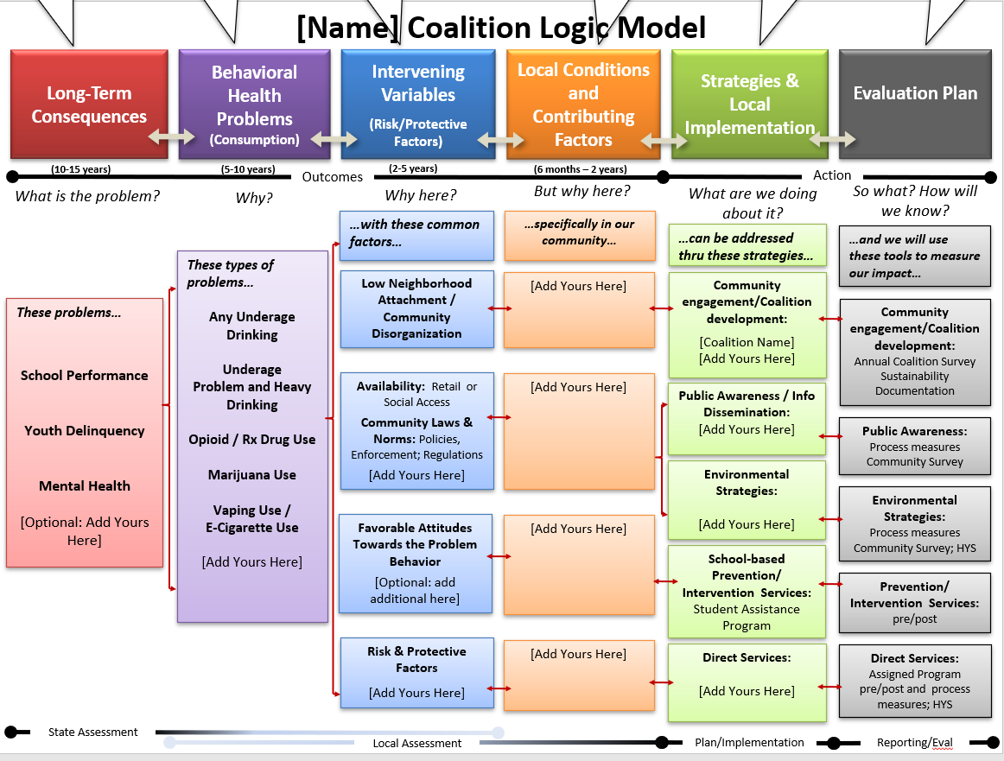

Appendix 5: Action Plan

Completing the Coalition’s Action Plan:
Include an Action Plan in the appendix of the Plan using the template provided on the Athenaforum.org in CPWI Guides. https://www.theathenaforum.org/tags/cpwi-guide-guidance-and-forms?page=1
The Action Plan should provide details for each goal, objective and strategy on the following:
- Activity/Program – Name of activity/program.
- Funding Source – See legend for list
- Brief Description – Briefly state the main purpose of the activity.
- How – How many times will the program be provided this year?
- When – List the implementation months of the activity.
- Who – Who is this service for? How many people will be reached?
- Lead – List the Organization delivering program.
- Responsible Party(ies) – Who from the Coalition is making sure this gets done?
Be sure to include, the Coalition meetings, sustainability, cultural competence, renewal of assessments, and review of evaluation information as part of the Coalition’s strategies and activities.
Follow Evidence-based Practice requirement(s) in contract.
*Work with your DBHR Contract Manager if needed. Below is a picture for reference.

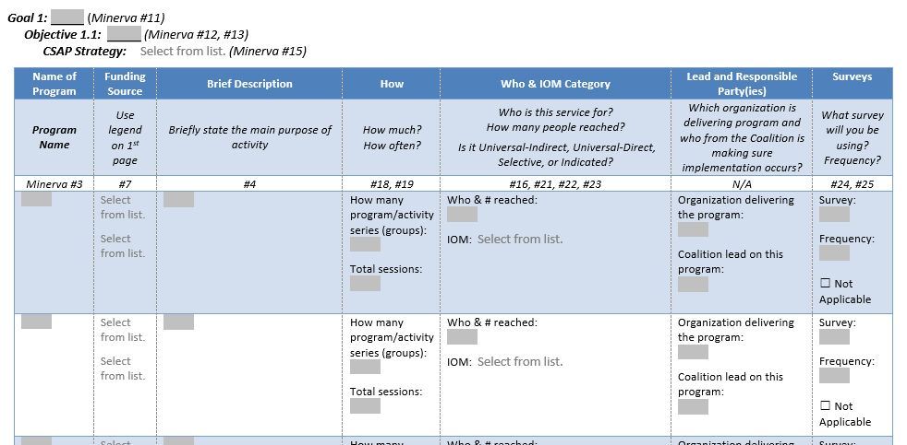

Action Plan SAMPLE
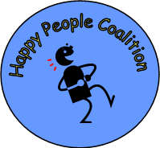
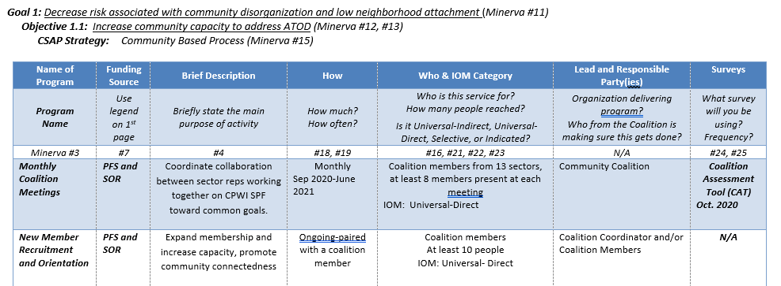
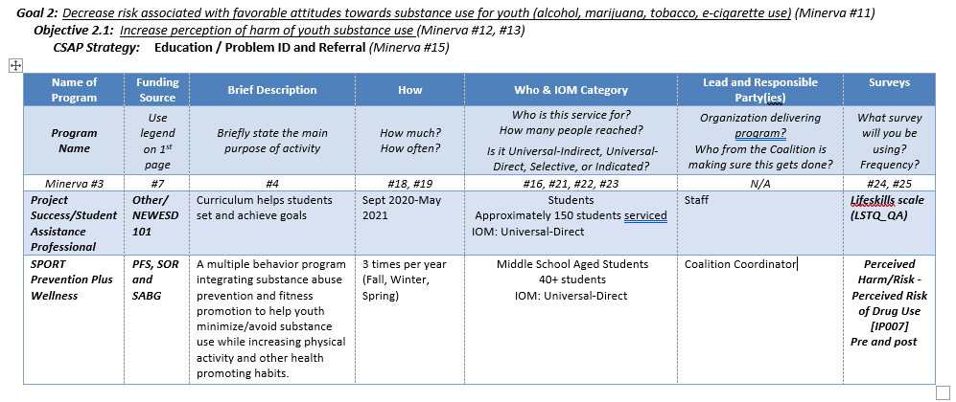
`

Appendix 6: Budget TEMPLATE
The budget detail should be submitted as a separate excel document with your Plan and does not need to be included in the required Appendix of the Plan. A Microsoft Excel template has been prepared for your use and can be found at https://www.theathenaforum.org/tags/cpwi-guide-guidance-and-forms

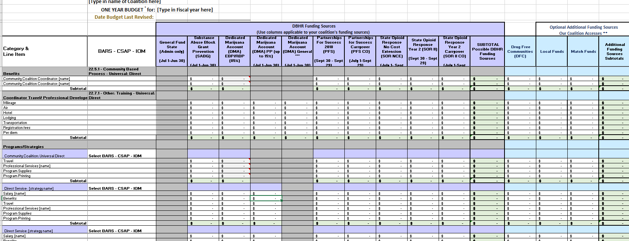

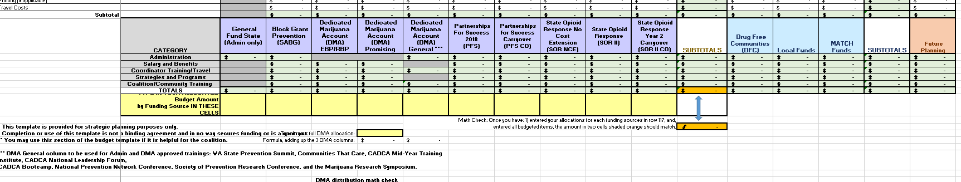

Appendix 7: Plan-on-a-Page TEMPLATE
This is an optional template for your use in working with the Coalition. It is intended to be a one-page summary of the various decisions the Coalition has made for the Plan. It can be a helpful to use as a communication piece for the Coalition and the broader community. The Coalition may choose to use this as the Executive Summary. The information on the following page is for reference. A Microsoft Word template has been prepared for your use and can be found at https://www.theathenaforum.org/plan-page-template-cpwi-strategic-plan

[Coalition Name & LOGO]
Summary Plan
Approved at Coalition Meeting on [DATE].
What | Mission: | What is the Coalition mission or vision statement?
 | Theory of Change: | What research framework is the Coalition using and how does that framework support the Coalition’s expected change in the community?
 | Strategies: | What strategies will the Coalition use? (E.g., environmental, direct services, community organizing, etc.)
 | Operating Principles: | What are key principles on which the Coalition bases their decisions?
How | Programs/ Projects/ Activities: | What programs, projects and/or activities is the Coalition doing?
 | Structure: | What is the organizational structure of the Coalition? (E.g., Full Coalition, Leadership committee, ad-hoc committees, youth councils, etc.)
 | Operational Functioning: | What are key operating functions? (i.e., How are decisions made? What are rules for membership, etc.?)
Resources | Funding: | What major sources of funds does the Coalition use?
 | Support: | What non-monetary resources does the Coalition have? (i.e., volunteers, staff, training, partnerships, etc.)

Plan-on-a-Page SAMPLE
This is a sample for your reference.
Happy People Coalition
Summary Plan
Approved at Coalition Meeting on March 15, 2021.

What | Mission: | The coalition is working to prevent youth violence and substance use disorder by working in and with communities to strengthen families and increase positive development.
 | Theory of Change: | Use Risk and Protective Factor research framework to change community and family outcomes, which will contribute to the reduction and prevention of youth violence and youth substance use.  Prioritized following risk factors:  - Community Disorganization and community connectedness.  - Social Access to Alcohol.  - Alcohol law enforcement and youth perception.  - School bonding, Social skills, and Friends who use.  - Poor Family Management.  - Favorable attitudes towards drug use and intentions to use.  And the protective factors of Bonding and Healthy Beliefs and Clear Standards.
 | Strategies: | Community engagement/Coalition development, Media Advocacy, and Service Collaboration; and Parent and Youth Education.
 | Operating Principles: | We believe in community involvement and inclusion in strategic planning and implementation. Our Coalition includes a wide variety of community members and youth, local non-profit organizations, school representatives, law enforcement, service agencies, parents and faith-based and business leaders.
How | Programs/ Projects/  Activities: | - Coalition Meetings (Monthly meetings of full coalition and leadership committee; ad-hoc meetings as needed)  - Media advocacy for improved enforcement, Law Enforcement Roundtable and Party Patrol.  - Student Assistance Program (Prevention-Intervention Specialist in middle school).  - Guiding Good Choices Parenting Program.  - LifeSkills Training student program.
 | Structure: | Local Community Coalition with Executive Leadership Committee and ad-hoc Planning Workgroups and Youth Council.
 | Operational Functioning: | Membership: voting members are to attend ¾ of the meetings annually. All partners and supporters are encouraged to participate as available. Meetings are open to the public.  Meeting Protocol: coalition uses Roberts Rules as general guidelines for facilitation of meetings and works to build consensus whenever possible. Coalition votes on key decisions regarding policy, fiscal and strategy decisions. Must have quorum to validate vote.
Resources | Funding: | Public and private sources.
 | Support: | Coalition volunteers.  Staffing support (.5 FTE Coalition Coordinator and 1.0 FTE P-I Specialist)  County/ESD/DBHR technical assistance.

Appendix 8: Understanding Community Survey Selection
The table below has been created using the WA HCA/DBHR system logic for measuring change in objectives to address risk and protective factors. It has been developed to assist users in the Minerva system to select the appropriate survey question banks based on the risk and protective factors identified for program selection and implementation. www.TheAthenaForum.org/Minerva
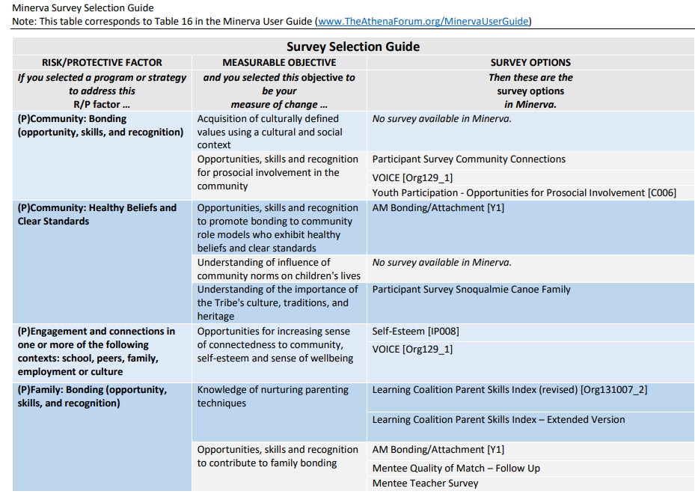
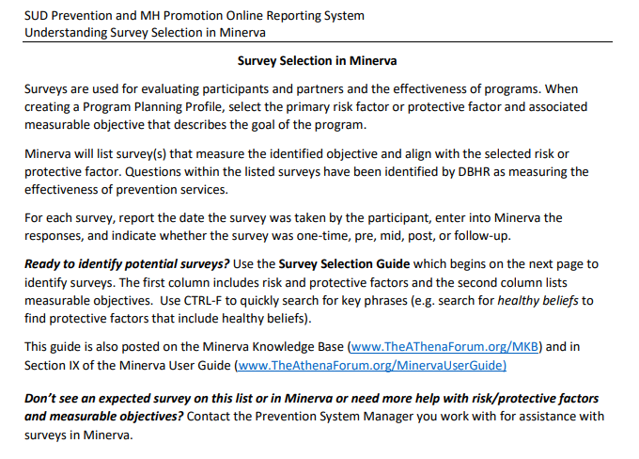

The document below has been created to help Coordinators understand the requirements to implement a Social Norms Campaign effectively. This can be helpful while you are building our your strategic plan! https://www.theathenaforum.org/community-library
