Using the TLC Library to locate a class

TLC Navigation
Instructions: Find the instruction number on the corresponding picture to find the area on the screen to click.

Click the Library Icon
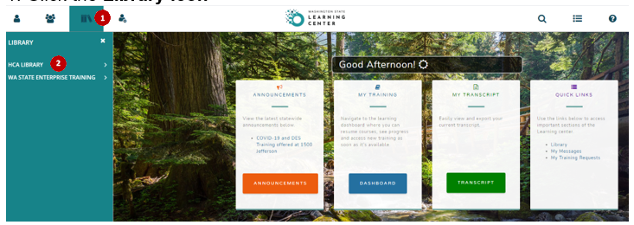
- Then click the ⋁ next to the HCA Library to expand your selection options
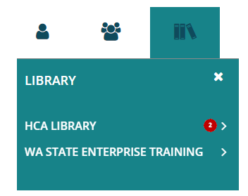

- Click on the library topic you are interested in to view the courses available then click on the course
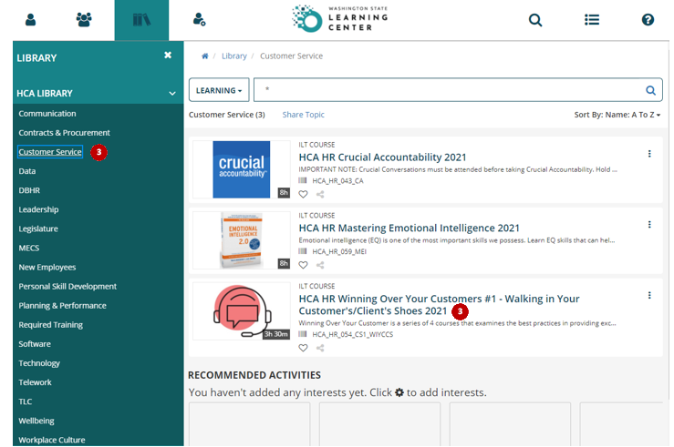
- A new window will open up with information about the course and any classes (activities) that are scheduled

Glossary of Terms
TLC | The HCA Learning Center (TLC)
ILT | Instructor led training

Contact your TLC HR Administrator at HCAHRTraining@hca.wa.gov

