Introduction:
The following packet contains information about a funding opportunity to support mental health and suicide prevention projects. There are separate awards available for each project. It is the Department of Social and Health Services/Division of Behavioral Health and Recovery’s (DSHS/DBHR) intention that selected projects will be sustained locally.
Project Deliverables:
- Within 90 days of contract execution, conduct a minimum of one Youth Mental Health First Aid (YHMFA) training for each award received. If an applicant receives both a Mental Health Promotion and a Suicide Prevention award, they will be required to provide two YMHFA trainings. YMHFA trainings shall: 1) be delivered using certified YMHFA instructors; 2) involve a minimum of 15 participants [5 of whom must be coalition members], and; 3) be held in the community served by the coalition.
Note: If an applicant receives both Mental Health Promotion and Suicide Prevention awards, the second required YMHFA training must be held before June 30, 2016.
- By January 31, 2016 a plan-to-plan must be submitted that provides timelines and processes for how the applicant(s) will develop their detailed implementation plan and budget.
- By March 31, 2015, submit a detailed implementation plan and final project budget – including the date that instruction of the selected programs is scheduled to start in local schools (if applicable) - is due;
- Begin implementation, with fidelity, the selected mental health promotion and suicide prevention programs identified in the implementation plan, as accepted by DBHR, no later than May 13, 2016;
- Coalition strategic plans, logic models and budgets shall be updated to reflect the additional mental health promotion and suicide prevention work, as necessary;
- Reporting of program activities shall be entered into the Performance Based Prevention System (PBPS) by the 15th of the month for the previous month’s activities; and,
- Community awareness of behavioral health issues and mental health promotion shall increase during the contract period as a result of media releases, news conferences, events, etc. A minimum of three (3) community awareness activities shall be implemented.
- These contracts are scheduled to terminate June 30, 2016, but may be extended depending on availability of resources.
Application Deadline:
January 19, 2016 – submit completed face sheet and required letters as email attachments to Martha Williams, PRItraining@dshs.wa.gov.
Mental Health Promotion and Suicide Prevention Project Overview GoTo Webinar
Because of the holiday season and vacation/schedule conflicts, we will be offering two different dates/times to participate in a virtual meeting for an overview of the mental health promotion and suicide prevention project funding opportunity.
Tuesday, December 29, 2015, 2 – 4 PM, 1. To join the meeting, click on this link, https://global.gotomeeting.com/join/276255989. The telephone number for audio is (224) 501-3412. The access code/meeting identification number is 276-255-989.
Tuesday, January 5, 2016, 10 AM – Noon. 1. To join the meeting, click on this link, https://global.gotomeeting.com/join/897747477. The telephone number for audio is (872) 240-3212. The access code/meeting
Mental Health Promotion and Suicide Prevention Project Description
Overall Purpose: | Increase the capacity for delivery of effective mental health promotion and suicide prevention efforts – and actual delivery of services - in communities served by community coalitions.
Eligible Applicants: | Eligible applicants include community substance abuse prevention, suicide prevention or health promotion coalitions or community based organizations providing services to support youth or communities.  Definitions:  “Coalition” – a formal arrangement for cooperation and collaboration between groups or sectors of a community. Each member group retains its individual identity, but all agree to work together toward a common goal of building a safe, healthy, and drug-free-community.  “Community-based organization” or “CBO” – a licensed and insured entity that has the potential to successfully serve youth and their families with selected program services. It may be a non-profit or faith-based organization.
Application Options | Single site applications  A single community coalition or community based organization can apply to do either a mental health promotion or suicide prevention project, or can submit an application for both.  If the application will lead to implementation of curriculum instruction work in local schools, the application will need to demonstrate support from the local school district and Educational Service District (ESD) serving the area.  In applications from coalitions, the agency or entity serving as fiscal agent will also need to demonstrate its support for the application.  Multi-site applications – Multi-site applications will receive scoring priority.  Two or more (up to five) coalitions/community-based organizations can apply as a multi-site to implement the same program(s). Multi-site application participants can either be totally separate organizations or individual members of a statewide or regional organization.  For multi-site applications that do not involve school-based curriculum instruction work, the participating coalitions will need to select one applicant organization.  ESDs will submit the applications – and serve as fiscal agent – for all multi-site applications that will lead to curriculum instruction in schools. In all such applications, local coalitions, school districts and ESDs will need to agree to use one selected program. All coalitions and local school districts will need to be within the service area of a single ESD.
Limitations: | - Applicant community coalitions or consortia may apply for the Mental Health Promotion and Suicide Prevention projects or just one of the projects. If both projects are applied for, the application letters will need to be written to address the requirements for both single projects.  - These are cost-reimbursement projects and there are no funds available for up-front costs.
Funding: | Grants will be awarded in two phases. Phase 1 = $5,000.00 for planning and delivery of a Youth Mental Health First Aid workshop. Phase 2 = increased contract to address approved implementation plan and budget.  Eighty-five percent (85%) of the total awarded funding must be spent on implementation of research-based programs identified in Appendix H. Up to 15% of the total awarded funding can be spent on Implementation of promising practices (Appendix I)  Coalitions/community-based organizations can apply for both research-based and promising practices awards but they need to be separate applications.  - There is $340,000 available to fund successful applications that use programs from the Research-based list (Appendix H).  Single applications  The maximum program budget will be a total of $20,000 per single application.  Single community coalitions or community-based organizations can submit applications for support. Each successful single applicant will be offered an initial Phase 1 contract of $5,000 for each successful application. These funds are intended primarily to cover increased staff and operating costs associated with getting research-based programs and practices implemented as well as implementation of the first Youth Mental Health First Aid (YMHFA) training in the community.  Single applications may be funded up to an additional $15,000 in Phase 2. Except for the initial $5,000 award, expenditures for selected programs will be authorized only on a case-by-case basis until an implementation plan is accepted.  Complete single applications must contain all of the elements described in the single application template.  Multi-site applications  The maximum program budget for multi-site applications will be a total of $17,500 per community.  In multi-site applications, the initial Phase 1 contract will be for $5,000 for each coalition or community-based organization involved in the application.  These funds are intended primarily to cover increased staff and operating costs associated with getting research-based programs and practices implemented as well as implementation of the first Youth Mental Health First Aid (YMHFA) training in the community.  Multi-site implementation plans may be funded in Phase 2 up to an additional $12,500 per community, or $45,000 total, whichever is lower. Except for the initial $5,000 award, expenditures for selected programs will be authorized only on a case-by-case basis until an implementation plan is accepted.  A multi-site application can seek funding for either Mental Health Promotion research-based programs or Suicide Prevention research-based programs or both.  Complete multi-site applications must contain all of the elements described in the multi-site application template.  - There is $60,000 available to fund successful applications that use programs from the Promising Approaches list (Appendix I).  Single applications  The maximum program budget for a promising practices award will be a total of $20,000 per single application.  Single community coalitions or community-based organizations can submit applications for support. Each successful single applicant will be offered an Phase 1 contract for $5,000 for each successful application. These funds are intended primarily to cover increased staff and operating costs associated with getting research-based programs and practices implemented as well as implementation of the first Youth Mental Health First Aid (YMHFA) training in the community.  Single applications may be funded up to an additional $15,000 in Phase 2. Except for the initial $5,000 award, expenditures for selected programs will be authorized only on a case-by-case basis until an implementation plan is accepted.  Complete single applications must contain all of the elements described in the single application template.  Multi-site applications  Multi-site applications will not be accepted for promising practices.
Eligible Expenses: | - Youth Mental Health First Aid - Costs for implementing training up to $2,000 (includes trainer and travel costs, meals, materials, and all other expenses associated with the training). It is also acceptable to use these funds to train YMHFA facilitators who will provide training workshops for your community.  - Implementation of selected research-based mental health promotion or suicide prevention programs or promising approaches for mental health promotion or suicide prevention – Allowable costs include: consulting with program developers to ensure “best fit”, training local instructors/facilitators to ensure program fidelity and associated travel costs, purchasing curriculum materials, and ongoing technical assistance from developers or other certified regional or state experts.  Funding awards are contingent upon an actual implementation of the selected program(s) by May 13, 2016.  It is acceptable to select and implement a new program from the list or to expand implementation of a program that is on the list that is presently being implemented in the local School District.  - Substitute teacher costs can be paid from this funding but cannot exceed 10 percent of the total budget.  - Personnel - Up to 20 percent of the total award can be used to support staff time to ensure effective planning and implementation of the selected program(s).  - Admin: The fiscal agent can bill for up to 8 percent of the total contract amount for administering the project(s).  Note: DBHR reserves the right to negotiate for project scope and funding.
Match: | The letter from the coalition must demonstrate a minimum of 20 percent match of the awarded amount. The match does not need to be cash, but applications that demonstrate cash match will receive scoring priority. Costs associated with substitute teachers and other instructional staff can be considered cash match for this project.  The initial Phase 1 contract will be for $5,000, so a minimum of $1,000 in match will need to be demonstrated in the initial application from each applicant. A multi-site application on behalf of five organizations would need to demonstrate a minimum of $5,000 match.  For the Phase 2 award, the detailed budget will need to demonstrate a minimum of 20 percent match for the entire budget.
Project Timeline: | - Planning for implementation should commence as soon as award announcements are made.  - Projects may start billing for reimbursement of expenses as soon as a contract is fully executed.  - Youth Mental Health First Aid training (YMHFA): A YMHFA training must take place within 90 days of contract execution for a single project award – Mental Health Promotion or Suicide Prevention – the required YMHFA training must take place within 90 days of contract execution.  For multiple awards, one YMHFA training shall be delivered within 90 days of contract execution and the other must be delivered before June 30, 2016.  - By January 31, 2016 a plan-to-plan must be submitted that provides timelines and processes for how the applicant(s) will develop their detailed implementation plan and budget.  - By March 31, 2015, submit a detailed implementation plan and final project budget – including the date that instruction of the selected programs is scheduled to start in local schools (if applicable) - is due;  - Implementation of the selected program(s) must begin before May 13, 2016.  - Reporting of activities implemented through these projects shall be entered into the Performance Based Prevention System (PBPS) by the 15th of the month for the previous month’s services, unless otherwise noted. All contract deliverables must be completed by June 30, 2016.  - Before August 31, 2016, all billings for reimbursement for project activities must be submitted.
Selection Criteria: | Only complete applications will be reviewed and scored. For the purposes of this project, a complete application is one that includes all required forms and letters and that completely answers each question. Scoring for each project is further defined in Appendix D.
Application Deadline: | Application deadline is 5 PM, January 19, 2016. Submit the completed registration form and required attachments to: Martha Williams at PRItraining@dshs.wa.gov.
Overview webinars | Because of the holiday season and vacation/schedule conflicts, we will be offering two different dates/times to participate in a webinar to provide an overview of the mental health promotion and suicide prevention project funding opportunity.  Tuesday, December 29, 2015, 2 – 4 PM, 1. To join the meeting, click on this link, https://global.gotomeeting.com/join/276255989. The telephone number for audio is (224) 501-3412. The access code/meeting identification number is 276-255-989.  Tuesday, January 5, 2016, 10 AM – Noon. 1. To join the meeting, click on this link, https://global.gotomeeting.com/join/897747477. The telephone number for audio is (872) 240-3212. The access code/meeting identification number is 897-747-477

Instructions for completing Request for Applications Face Sheet
- Indicate whether this is a single application or multi-site application by either circling or underlining your response.
- Indicate whether this is application will support school-based or community- or family-based services by either circling or underlining your response.
- Indicate whether this application will use research-based programs or promising practices by either circling or underlining your response.
- Indicate whether this application is for mental health promotion or suicide prevention funding, or both, by checking either - or both - boxes.
The requirements for mental health promotion and suicide prevention grants appear below:
Mental health promotion - conducting Youth Mental Health First Aid training with coalition or community-based organization members and community members and implementing one of evidence-based programs or promising approaches for mental health promotion.
Suicide prevention - conducting Youth Mental Health First Aid training with coalition or community-based organization members and community members and implementing one of evidence-based programs or promising approaches for suicide prevention. Optional activities include: training educational professionals in Networks for Life, training counselors in the community in suicide awareness and referral, and/or, implementing means access reduction training, lethal means restriction education and materials and support for emergency rooms and emergency service providers.
- Provide information about the applicant organization.
The applicant organization will be the organization that submits the application to DBHR and that agrees to administer the contract if the application is funded.
For multi-site applications that will involve use of school-based curriculum, the applicant organization must be the ESD serving the local school districts involved in the application.
For multi-site applications focused on community- or family-based interventions, one of the coalition applicant organizations, community-based organizations, local school districts or the ESD could be the applicant organization.
- Who is involved in the application?
Single applications that will focus on school-based curriculum instruction need one coalition or community based organization, one local school district and one ESD identified. Single applications focusing on community- or family-based services need one coalition or community-based organization identified.
Multi-site applications that will focus on school-based curriculum instruction need at least two (and not more than five) coalitions and/or community-based organizations, local school districts and one ESD that supports each of the local school districts. Multi-site applications focusing on community- or family-focused services, need to be at least two (and not more than five) coalitions and/or community-based organizations.

Required Letters for Applications:
If application is to support school-based services – all four of the following letters are required
- Community coalition and/or community-based organization letter (signed by the authorized signer for the organization). This letter template is found in Appendix A.
- Local school district (signed by the authorized contract signer for the district). This letter template is found in Appendix B.
- Educational Service District (signed by the authorized signer for the ESD). This letter template is found in Appendix C.
- Applicant organization (signed by the authorized signer for the organization). This letter template is found in Appendix D.
If application is to support community- or family-based services
- Community coalition and/or community-based organization letter (signed by the authorized signer for the organization). This letter template is found in Appendix A.
- Applicant organization (signed by the authorized signer for the organization). This letter template is found in Appendix D.

Note: The Request for Applications Face Sheet along with each of the specified letters must be submitted at the same time to be considered a complete application.

Further, all applicable questions for each element of the application must be complete in order to be considered a complete application.

Mental Health Promotion and Suicide Prevention Applications

Application Face Sheet

- Applicant Organization

The applicant organization submits the application and agrees to accept the contract associated with the project if the application is selected for funding.
- Applicant Organization Name:
- Mailing Address:
- Applicant Organization Authorized Signer Name:
- Applicant Organization Authorized Signer Email:
- Applicant Organization Authorized Signer Phone:
- Applicant Organization Authorized Signer Signature:
- DUNS Number for Applicant Organization:
- 9-digit Zip Code for Applicant Organization:
- State Vendor Number for Applicant Organization (If you currently do not have a State Vendor Number please follow the directions on Page 29 so you can secure one to submit with this package):

- Please indicate type of application:
single application
multi-site application
- This application will be supporting:
school-based programs
community- or family-based programs
- This application will support implementation of:
Researched based programs (Appendix H)
promising practices (Appendix I)
- This application is for funding for the following project(s). (Please check all that apply):
Mental Health Promotion
Suicide Prevention
- Who is involved in the application? (Please list all participants in this application in the spaces below.)
Community coalition(s) or community-based organization(s)
 | Name of coalition/community-based organization | Contact person (if different than applicant organization) | Letter included
1 |  |  | Yes No
2 |  |  | Yes No
3 |  |  | Yes No
4 |  |  | Yes No
5 |  |  | Yes No
Local school districts (Required if application is to support school-based curriculum instruction)
 | Name of local school district | Contact person (if different than applicant organization) | Letter included
1 |  |  | Yes No
2 |  |  | Yes No
3 |  |  | Yes No
4 |  |  | Yes No
5 |  |  | Yes No
Educational Service District (ESD) (Required if application is to support school-based curriculum instruction)
 | Name of Educational Service District (ESD) | Contact person (if different than applicant organization) | Letter included
1 |  |  | Yes No

Appendix A – Coalition/Community-based Organization template letter
Date
Martha Williams
Division of Behavioral Health and Recovery
P.O. Box 45330
Olympia, WA 98504-5330
RE: Application for funds
Dear Ms. Williams:
Please accept this letter of application for funding from the DBHR Mental Health Project from the _ (Name of coalition/community-based organization) that serves ___ _____ (Name of Community).
Questions (Responses to Questions A-G are required for all applications)
- The coalition/community-based organization is / is not (Please circle or underline one) currently a participant in the Division of Behavioral Health and Recovery’s Community Prevention and Wellness Initiative (CPWI).
- Please identify the name and title of the individual from the coalition who will update the coalition strategic plan, logic model and budget to include these additional program implementation. (Note: In a multi-site application involving multiple CPWI coalitions, each CPWI coalition will need to respond to this question);
- The coalition/community-based organization did / did not (Please circle or underline one) receive either Mental Health Promotion or Suicide Prevention funding from DBHR in the past year.
- Statement of community need from __ ___ (Name of community).
From the coalition or community-based organization’s viewpoint, the following information demonstrates community need for efforts to reduce behavioral health issues and their impact on the community and families.
In this section, please include information about:
- The community’s mental health and behavioral health needs based on elevated depression and/or suicide indicators as demonstrated through Healthy Youth Survey and other information demonstrating elevated mental health problems among the community’s youth.
- Impacts of these issues that have been seen in the community and families.
- Importance of accessing these funds for addressing the community’s behavioral health issues.
- Local information about recent behavioral health-related incidents, including suicides.
- Please identify funds and resources that will be leveraged at the local level to support and maintain the efforts, especially the required 20 percent match. In this application, the initial award for each applicant will be $5,000, so match of $1,000 must be demonstrated for each community coalition/community-based organization involved with the application.
- Please list the partners involved to support this/these project(s) in the coalition’s community;
- Please explain how the coalition, ESD, and School District will work together to implement three activities during the contract period to increase community awareness about behavioral health issues and mental health promotion;
- Please describe what mechanisms are in place (or will be developed) to ensure this will occur:
- Check here to indicate that you understand that payment of project billings will be contingent on timely and complete reporting of project activities in DBHR’s Performance Based Prevention System (PBPS).
Respond to Question H only if the funds from a successful application will go to support school-based programs:
- Check the box to demonstrate that the ____ ______ (Name of coalition/Community-based organization) will commit to coordinating with ____ ______ (Name of Educational Service District) and ___ _____ (Name of school district) to develop and submit a plan to plan document by January 31, 2015 and a detailed plan for implementing the selected program(s) by March 31, 2016. The implementation plan shall contain information about a process to collaboratively select programs to implement as well as a specific date when the selected program(s) will begin being implemented;
- Please describe what mechanisms are in place (or will be developed) to ensure this will occur.
Thank you for consideration of this application.
If you have any questions, or need additional information, please contact ___ ___ (Name of coalition/community-based organization contact person) at ___ ___ (Phone Number) or __ ______ (Email address).
Sincerely,

Coalition Chair/Community-based Organization Name
Coalition/Community-based Organization Name
Appendix B – School District template letter
Date
Martha Williams
Division of Behavioral Health and Recovery
P.O. Box 45330
Olympia, WA 98504-5330
RE: Application for funds
Dear Ms. Williams:
Please accept this letter of application for funding from the Mental Health Project.
Questions (Responses to these questions are required if this application is for support of school-based programs or services)
- Statement of concern from ____ ____ (Name of school district) school district’s viewpoint about behavioral health issues and mental health promotion in the district and community, their impact on the community’s schools and support from the ____ _____ School District to address those issues.
In this section, please include information about:
- School district-specific behavioral health issues.
- Efforts the district has undertaken to address these issues in the past and any future plans the district has for addressing the issues.
- Indicate an understanding about how the behavioral health issues impact students and staff in the schools and the community in general.
- Provide a statement of support for this project and how important the funding is to begin addressing the identified problems.
- Check here to indicate that the ___ ___ (Name of school district) agrees to play an active part in developing the plan-to-plan document due January 31, 2016 and the detailed implementation plan and budget due by March 31, 2016.
- Please describe what mechanisms are in place (or will be developed) to ensure this will occur:
- Check here to indicate that the district agrees to commit to a specific date before May 13, 2016 to begin implementing the selected programs and that date will be included in the detailed implementation plan for this project.
- Check here to indicate that the ____ _____ (Name of school district) agrees to coordinate with other partners in this application to implement three activities during the contract period to increase community awareness about behavioral health issues and mental health promotion.
- Check here to indicate that you understand that payment of project billings will be contingent on timely and complete reporting of project activities in DBHR’s Performance Based Prevention System (PBPS).
Thank you for consideration of this application.
If you have any questions, or need additional information, please contact ____ ________ (Name of school district contact person) at ___ ______ (Phone Number) or ___ ______ (Email address).
Sincerely,

Name of School District authorized signer and title
School District Name

Appendix C – Educational Service District template letter
Date
Martha Williams
Division of Behavioral Health and Recovery
P.O. Box 45330
Olympia, WA 98504-5330
RE: Application for funds
Dear Ms. Williams:
Please accept this application for funding from the DBHR Mental Health Project.
Questions (Responses to these questions are required if this application is for support of school-based programs or services)
This is an individual application / part of a multi-site application. (Please circle one)
- Statement of concern from viewpoint of ___ ___ Educational Service District (ESD) about behavioral health issues, impacts on the schools and community, and support from the ESD to address those issues.
In this section, please include information about:
- Behavioral health issues, especially in the community or communities involved in this application.
- Describe efforts the ESD has undertaken to address these issues in the past and any future plans the district has for addressing the issues.
- Indicate an understanding about how the behavioral health issues impact students and staff in the schools and the community in general.
- Provide a statement of support for this project and how important the funding is to begin addressing the identified problems.
- Check here to indicate that the ____ ____ Educational Service District agrees to play an active part in developing the plan-to-plan document due January 31, 2016 and the detailed implementation plan and budget due 120 days following contract execution.
- Please describe what mechanisms are in place (or will be developed) to ensure this will occur:
- Check here to indicate that the ESD will work with the other application partners to implement three activities during the contract period to increase community awareness about behavioral health issues and mental health promotion;
- Check here to indicate that you understand that payment of project billings will be contingent on timely and complete reporting of project activities in DBHR’s Performance Based Prevention System (PBPS).
Thank you for consideration of this application.
If you have any questions, or need additional information, please contact ____ ______ (Contact person for Educational Service District) at _____ _____ (Phone Number) or ____ ____ (Email address).
Sincerely,

Name of ESD authorized signer and title
Educational Service District Name

Appendix D – Applicant Organization template letter
Date
Martha Williams
Division of Behavioral Health and Recovery
P.O. Box 45330
Olympia, WA 98504-5330
RE: Application for funds
Dear Ms. Williams:
Please accept this letter of application for funding from the DBHR Mental Health Project.
Questions (Responses to each question is required)
Check if the _____ ______ (Name of organization) agrees to be the applicant organization for this project, as requested by the ___ ____ (Name of coalition).
- Check here to indicate that you understand and agree that the maximum “admin” charge for this project is eight (8) percent of the total value of the contract and from that amount of funding your organization will provide – at a minimum - budget tracking, fiscal status reporting, and reimbursement billing for this project.
- Check here to indicate that you understand that this is a cost reimbursement contract and that there are no up-front funds available to support operation of the project.
- Check here to indicate that your organization is a governmental agency, school district or college, or that you have private not-for-profit status.
- Check here if your organization is currently in good standing with your other grant-funded projects.
- Check here if you have contracted with DBHR during the past two years. If you have contracted with DBHR, but have made changes in who can sign contracts, please complete the “Contractor Update Form” in Appendix G and return it with the other application materials.
  - If you have not been a contractor with DSHS within the past two years, please complete the New Contractor Intake forms found on Pages 25-28 and return with the application materials.
  - If you have been a contractor with DSHS within the past two years, but have changes in your organization (especially with authorized signers), please complete the Contractor Update form on Page 31.
  - You do not need to submit any additional information if you have been a contractor with DSHS within the past two years and nothing has changed in your organization.

Fiscal contact information (if different than the Request for Application Face Page):
Name of fiscal contact for this project:
Fiscal contact mailing address:
Fiscal contact telephone:
Fiscal contact email:
Thank you for consideration of this application.
If you have any questions, or need additional information, please contact _____ ________ (Contact person for applicant organization) at ____ _______ (Phone Number) or __ _______ (Email address).
Sincerely,
Name of Applicant Organization authorized signer and title
Applicant Organization Name

Appendix E – Scoring Criteria
Mental Health Promotion and Suicide Prevention Project Application Scoring
The Application Face Sheet shall be completed and submitted with the remainder of the requested information. The letters from community coalitions, local school districts, Educational Service Districts and applicant organizations are expected to provide brief – yet complete – narrative answers to all questions.
If applicant does not respond to any of the required questions, the application may be disqualified. If applications score the same, and the number of applications exceeds the amount of funding available, preference will be given to complete applications with earlier submission dates and times. DBHR reserves the right to follow up with applicants to obtain more information about the application.
Community Name (if individual application):
 | Has the community received Mental Health Promotion or Suicide Prevention funding from DBHR in the past year? (Yes = 0 points, No = 5 Points) (For multi-site applications, these points will only be given if none of the organizations received this funding in the past year.) | Yes No
 | Is this a multi-site application? (Yes = 5 points, No = 0 points) | Yes No
 | Are required letters included?  For applications for community- or family-based services – letters from each coalition and/or community-based organization letter, applicant organization letter  For applications for school-based services – letters from each coalition and/or community-based organization, applicant organization, each local school district letter and Educational Service District letter  (Yes = 5 Points; No = 0 Points) | Yes No
 | Are responses provided to all required questions in each required letter?
 | Coalition/Community-based Organization Letter (Items A-I)  (Yes = 5 Points; No = 0 Points) | Yes No
 | Local School District (Items A-E)  (Yes = 5 Points; No = 0 Points) | Yes No
 | Educational Service District (Items A-D)  (Yes = 5 Points; No = 0 Points) | Yes No
 | Applicant organization (Items A-E)  (Yes = 5 Points; No = 0 Points) | Yes No

 | Question H – If the application is for school-based programs or services is a response provided to this question? (Yes = 2 Points; No = 0 Points) |  | Yes No
 | Use the scale to the right to indicate how completely community need is demonstrated in the Coalition/Community-based Organization letters, Item C). (For multi-site applications, maximum points will only be given if all of the letters completely address all of the required elements.) | Some required elements are not demonstrated at all in the narrative(s) - 0 | Some required elements are not completely demonstrated in the narrative - 3 | All required elements are completely explained in the narrative(s) - 5
 | Is there financial need demonstrated for support of this project in the Coalition/Community-based Organization letter, Item C?  (Yes = 5 Points; No = 0 Points) |  | Yes No
 | Use the scale to the right to describe how completely the applicant demonstrates the match requirement. (Coalition/Community-based Organization letter, Item D). (For multi-site applications, maximum points will only be given if all of the letters completely address all of the required elements.) | Less than 20% match is demonstrated - 0 | 20 % match demonstrated BUT cash match makes up less than 50% of the total match - 3 | 20 % match demonstrated AND cash match makes up more than 50% of the total match - 5
 | Are community partnerships identified in the Coalition/Community-based Organization letter, Item E?  (Yes = 5 Points; No = 0 Points) |  | Yes No
 | Use the scale to the right to indicate how completely the School District demonstrates an understanding of behavioral health issues in the district and the need to address them. (School District letter, Item A) (For multi-site applications, maximum points will only be given if all of the letters completely address all of the required elements.) | Some required elements are not demonstrated at all in the narrative(s) - 0 | Some required elements are not completely demonstrated in the narrative - 3 | All required elements are completely explained in the narrative(s) - 5
 | Use the scale to the right to indicate how completely the Educational Service District (ESD) demonstrates an understanding of the importance of dealing with behavioral health issues. (ESD letter, Item A) (For multi-site applications, maximum points will only be given if all of the letters completely address all of the required elements.) | Some required elements are not demonstrated at all in the narrative(s) - 0 | Some required elements are not completely demonstrated in the narrative - 3 | All required elements are completely explained in the narrative(s) - 5
Date and time application was submitted to DBHR:
Total score, Items 1-11: ________

Appendix F - New Contractor Intake Forms
Forms can be found at: http://www.theathenaforum.org/sites/default/files/Contractor%20Intake%20Form%20for%20DSHS%20Contracts.doc

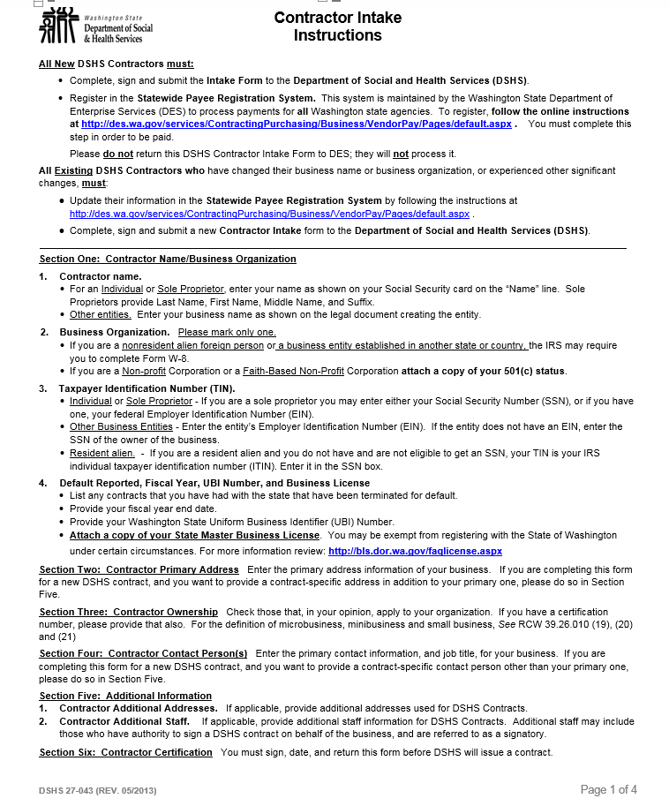
SAMPLE
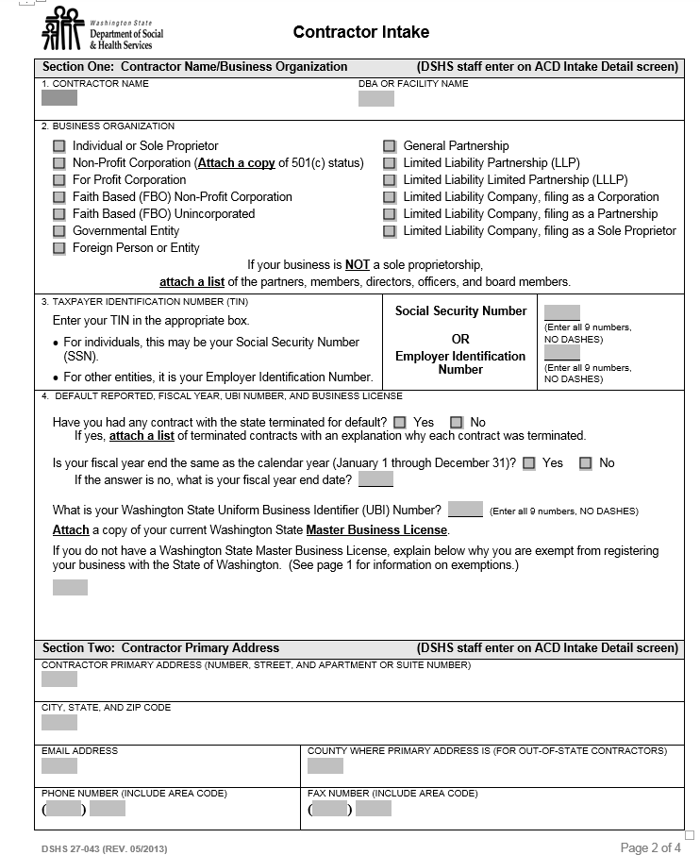
SAMPLE
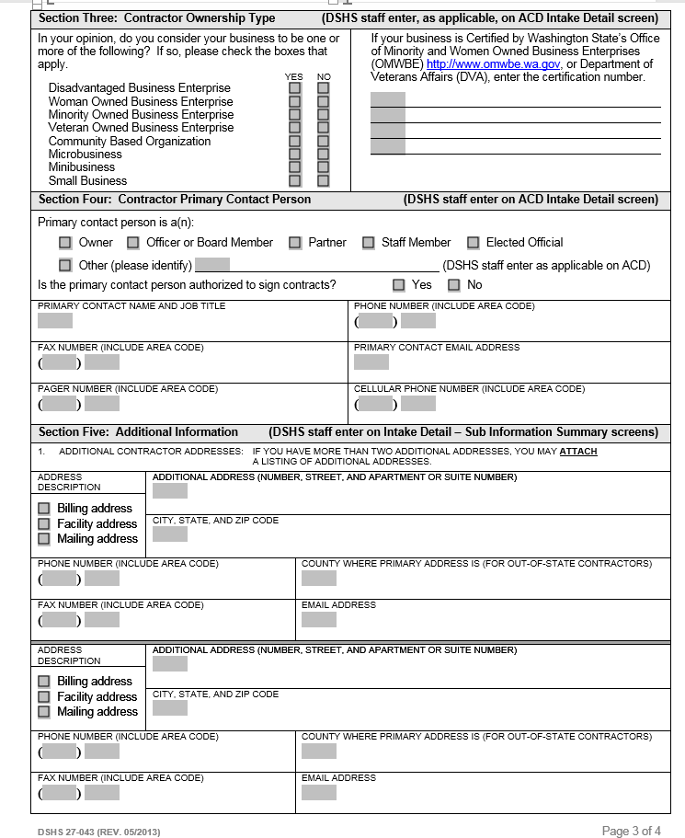
SAMPLE

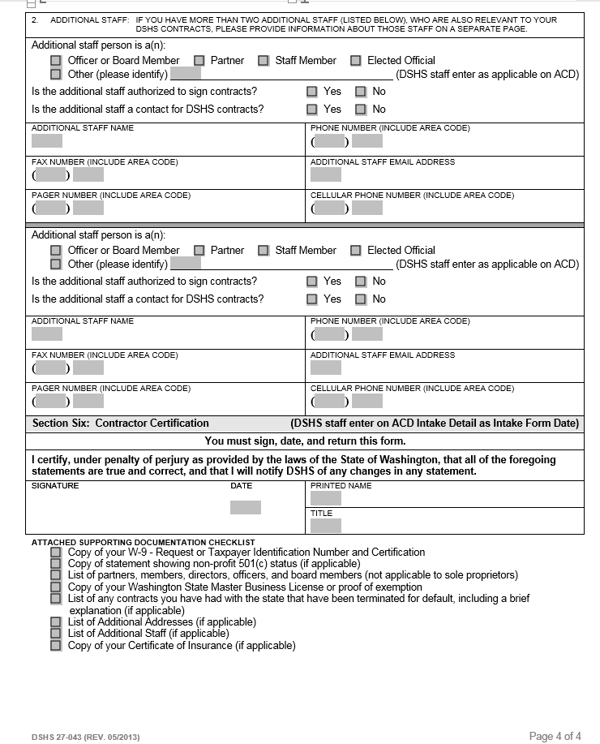
SAMPLE
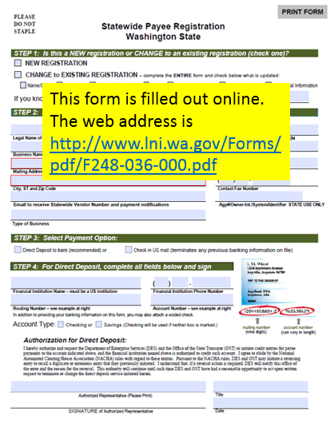
Appendix G – Existing Contractor Change Form

SAMPLE

Appendix H - Research-Based Programs for Mental Health Promotion (10) and and Suicide Prevention (2) Projects

Research-Based Programs for Mental Health Promotion (10) and Suicide Prevention (2) Projects
Index for list
- = Programs that have identified dual outcomes for mental health promotion and either general substance abuse prevention outcomes or marijuana-specific prevention outcomes
Mental Health Promotion
School-based interventions - Universal
- Good Behavior Game (GBG) * or PAX Good Behavior Game *
- Lions Quest Skills for Adolescence *
- New Beginnings Program
- Positive Action *
School-based Interventions - Indicated or Selective Programs
- Primary Project *
Family-focused Interventions - Universal
- Guiding Good Choices *
- Incredible Years *
- Parent Corps
- Parenting Management Training - The Oregon Model (PMTO)
- Strengthening Families Program: For Parents and Youth 10-14 (Iowa Version) *
Suicide Prevention
School-based – Universal
- Sources of Strength
School-based – Selective and Indicated
- CAST (Coping and Support Training) *

Appendix I - Promising Practices for Mental Health Promotion (5) and Suicide Prevention Projects (1)

Promising Practices for Mental Health Promotion (5) and Suicide Prevention Projects (1)
Mental Health Promotion
School-based Interventions - Universal
- Early Risers (Skills for Success) *
- Fourth R (Skills for Youth Relationships) *
- Second Step *
Community-based Intervention – Universal, Selective, Indicated
- Triple P (Positive Parenting Program)
Family-focused interventions – Universal, Selective
- Chicago Parenting Program
Suicide Prevention
Community- based – Universal
- QPR (Question, Persuade, Refer)

