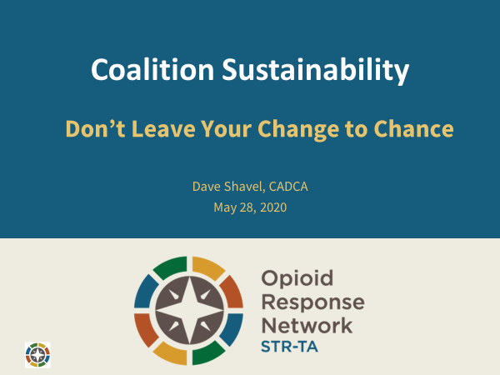

Handouts

Coalition Sustainability Checklist

Coalition: Date:

Yes! | Sort of | No! | ???? | Criteria
Strong Volunteer and Membership Base
 |  |  |  | New members and volunteers are actively recruited, oriented and trained
 |  |  |  | The coalition promotes relationships among members and volunteers
 |  |  |  | Coalition members and volunteers are provided clear roles and responsibilities
 |  |  |  | Recognition and Rewards are provided to coalition members
A Credible Process
 |  |  |  | The coalition uses an evidence- and data-based Strategic Planning process
 |  |  |  | Coalition members are trained and actively involved in the planning processes
 |  |  |  | The coalition uses planning products to guide its the work in the community
 |  |  |  | The coalition updates its planning products on a regular basis
Relevance to current community concerns
 |  |  |  | The community is aware of how substance use relates to community issues
 |  |  |  | The coalition monitors community issues and priorities
 |  |  |  | The community is aware of what the coalition and its partners are doing
 |  |  |  | The coalition shares result / outcomes from the coalition and partners
Financial and other resources required to do the work.
 |  |  |  | The coalition conducts an inventory of current resources
 |  |  |  | The coalition identifies future resource needs
 |  |  |  | The coalition has identified diverse funding strategies
 |  |  |  | The coalition has identified potential sources and donors
 |  |  |  | The coalition has created case statements
 |  |  |  | The coalition has an action plan to obtain identified resources

What elements need to be addressed?

1.

2.

3.

What additional information is needed?

Comments:

Sustainability Plan Template

Case Statement:

Existing Resources/Termination Dates:

What needs to be sustained?

What resources are required?

Key Strategies and Sources to Meet the Areas of Need:

Strategies | Potential Sources - Actions

Action Plan to Implement Strategies:

Task | By Who? | By When? | Resources Required | Who needs to know?

Contact Information:

Case Statement:
Sustainability Plan ‐ Acme County CARE Coalition

The Acme County CARE Coalition has been instrumental in reducing marijuana and alcohol use and misuse by youth in our community. The coalition makes a difference by utilizing strategies that have been proven successful and are driven by scientific research. The work of the Acme County CARE Coalition has proven to be an essential component to reducing substance use and use and misuse in our community through prevention efforts such as community and family education, coalition partner trainings, student programs, special events and advocacy. It is imperative to sustain our work that has produced a verified decrease in substance usage and made significant strides in building stronger families for Acme County.

One of the things that sets us apart, is that the coalition is composed of concerned and committed citizens representing 12 different sectors who have been trained to utilize strategic planning to achieve its goals. By using volunteers and in‐kind contributions we have been able to keep costs to a minimum, however it’s essential to diversify our sources of funding to ensure the stability and longevity of the coalition and its contribution to the community. So, to ensure the continuation of this important work, we need your help in sustaining our qualified and dedicated staff, suitable office facilities, and updated communication tools and applications. When we work together as a community – we can make a difference and create a safe and healthy place for our youth and families.

Existing Resources/Termination Dates:

$125,000 | DFC | Expires 9/30/2021 | Funds 2 Staff, Office Space, Utilities
$3,000 | OVUC Donations | Expires 12/31/19 | Funds Mentor Program Staff & Supplies
$7,500 | Champions Foundation | Expires 6/30/20 | Funds Youth Programs Staff & Supplies
$27,000 | Fund Raising Event | Annual | Funds Policy Board Staff and Supplies
What needs to be sustained?

In order to achieve our goals, the following outcomes and strategies must be sustained:
- Reducing substance use and misuse rates through the development of effective environmental strategies that are culturally appropriate and community based.
- Building the capacity of coalition and community members to use SAMHSA’s Strategic Prevention Framework and other strategies to address substance use and misuse issues through support of sustainable, integrated prevention programs.
- Increasing the availability of local substance use and misuse prevention services to at‐risk youth and adults in the targeted population groups.
- In order to achieve these outcomes, the following efforts must be sustained: Community Advisory Coalition (CAC), Youth Engagement in Environmental Prevention Strategies and Policy‐based strategies to achieve community‐level change.

What future resources are required?

The following resources are required to sustain this collaborative community effort:
- Two full time staff with combined salaries and benefit costs of $150,000
- A periodic Student Health Survey, professional comprehensive analysis $11,000 per 2‐year cycle.
- Programmatic costs such as office supplies, computers, phones, copies, food for meetings, and rental costs for offices and meeting spaces. $20,000
- Training for coalition members $10,000
- Professional consultants for various trainings such as alcohol retailer trainings & law enforcement training: $9,000
Total Costs per year: $200,000

Funding Strategies and Sources:

Specifically, the coalition will seek to obtain the $200,000 in required funding in the following ways:

Strategies | Potential Sources ‐ Actions
1. Fundraisers 10% = $20,000 | Partner with ACME Kiwanis Club to sponsor Golf Tournament.  Partner with local businesses to sponsor Family Night fund raisers
2. Grants = 25% = $50,000 | Apply for local foundation grants. Identify grants that fund coalitions, health initiative and infrastructure.
3. Line Item in County Budget –  County Commissioners 20% = $40,000 | Develop relationship with Acme County Commissioners by establishing semi‐annual meetings and other communications with each County Commissioner. Assign coalition members to follow up with each Commissioner
4. In‐kind contributions 30% = $60,000 | Coalition members to donate their time to coalition efforts. Establish a “time bank” to record and reward coalition members for their efforts.
5. Fees for Services 10% = $20,000 | Charge for Court Ordered Classes for DWI Citations. Work with courts and law enforcement of each city within ACME County to coordinate classes.
6. Membership Dues 5% = $10,000 | Begin a dialogue with Coalition members about sustainability and the need to diversify resources. Discuss range of potential dues for coalition members.

Action Plan to Implement Strategies:

Task | By Who? | By When? | Resources Required | Who needs to know?
1. Approach Kiwanis Club to discuss potential fund raiser. | Tina Grey | June 25 | One‐pager coalition description | Kiwanis Leadership
2. Research, Prepare and Submit Requests to Applicable Foundations and Grant Opportunities | Steve Garvey | Aug 15 | Access to Foundation Database | Coalition Board of Directors & Partner Organizations
3. Conduct quarterly presentations to County Commissioners | Jalen Kennedy | July 4 | Format for one‐pager for County Commissioners | County Commission Staff
4. Establish recognition program for coalition volunteers. | Mary Ying | September 30 | Database to record coalition member time. | Coalition Board of Directors
5. Train Facilitators and Organize Logistics. Establish Agreement with Courts. | Hector Rodriguez | October 1 | TOT material from curriculum developer | Chief Judge of Courts
6. Put Sustainability on Coalition Agenda. Publish report card reporting accomplishments to share with coalition members | Chantelle Henderson | September Coalition Meeting | Examples of Report Card formats | Coalition Board of Directors

Contact Information:

Sondra McKenzie, Acme County Coalition Coordinator 22 Community Center St
Acme City, VA 02200 Phone, Cell, Email, website

