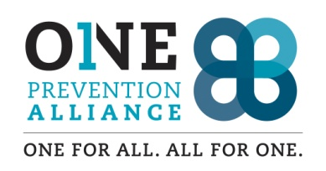
Volunteer Application Form
Name:
Address: City: Zip Code:
Phone: #1 #2
Email:
Emergency Contact: Phone

Past Volunteer Experience (include organization/agency, position, and supervisor phone/email)

Employment (include most recent company, position, supervisor phone/email)

What do you feel are the most urgent issues we face as a community regarding underage drug and alcohol use?

Desired Schedule (check days & times available)
( ) Monday ( ) Friday ( ) Morning (9am-noon)
( ) Tuesday ( ) Saturday ( ) Afternoon (noon-4pm)
( ) Wednesday ( ) Sunday ( ) Evening (4-8pm)

Frequency of Volunteer Availability (e.g., weekly, semiweekly, monthly, project specific, limited duration):
Why do you want to volunteer with OPA?
What are your hobbies, interests and skills?
What are your specific areas of interest in working with OPA? Check all that apply.
( ) Working with Parents & Children ( ) Working with Parents
( ) Working with the Elementary Schools ( ) Working with the School District
( ) Working with the Middle School ( ) Working with the High School
( ) Working with the Alternative School ( ) Working on an OPA Committee
( ) Media/Communications ( ) Drug Take Back
( ) Social Media (Facebook/Website) ( ) Hot Spots
( ) Graphic Design ( ) Local Festivals/Celebrations
( ) County, State and/or Federal Agency ( ) Other projects
( ) Community Outreach ( ) Marketing campaigns
( ) Special Projects ( ) Available as needed

Do you have children? If yes, what are their age(s)?

Is/Are your child(ren) in school? If yes, what grades? What school(s)?

Is there additional information you would like to share regarding your interest in OPA, how you would like to volunteer or skills/abilities you could bring to our coalition?

References: Give name, address and phone/email of three non-family members who are personal character references.
1.
2.
3.

