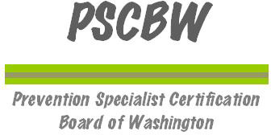

***Registration Deadline Extended to Feb. 6th. Now open to participants from any location in the state.***

*Substance Abuse Prevention Skills Training (SAPST)*

Tuesday, February 12, 2013, 8:30 a.m. through Friday, February 15, 2013, noon

Yakima Area Arboretum, Solarium Room

1401 Arboretum Drive, Yakima, WA 98901

The Prevention Specialist Certification Board of Washington (PSCBW) is pleased to provide this Substance Abuse Prevention Skills Training based upon a national curriculum developed by the Center for Substance Abuse Prevention (CSAP). Financial support is provided by Division of Behavior Health and Recovery Services (DBHR).

This is the new Substance Abuse Prevention Skills Training (SAPST) which is replacing the Substance Abuse Prevention Specialist Training (a.k.a. SAPST). The main purpose of this new SAPST is to train the participant in the Strategic Prevention Framework (SPF). This three and one-half day training will cover modules depicted in the following SPF graphic:

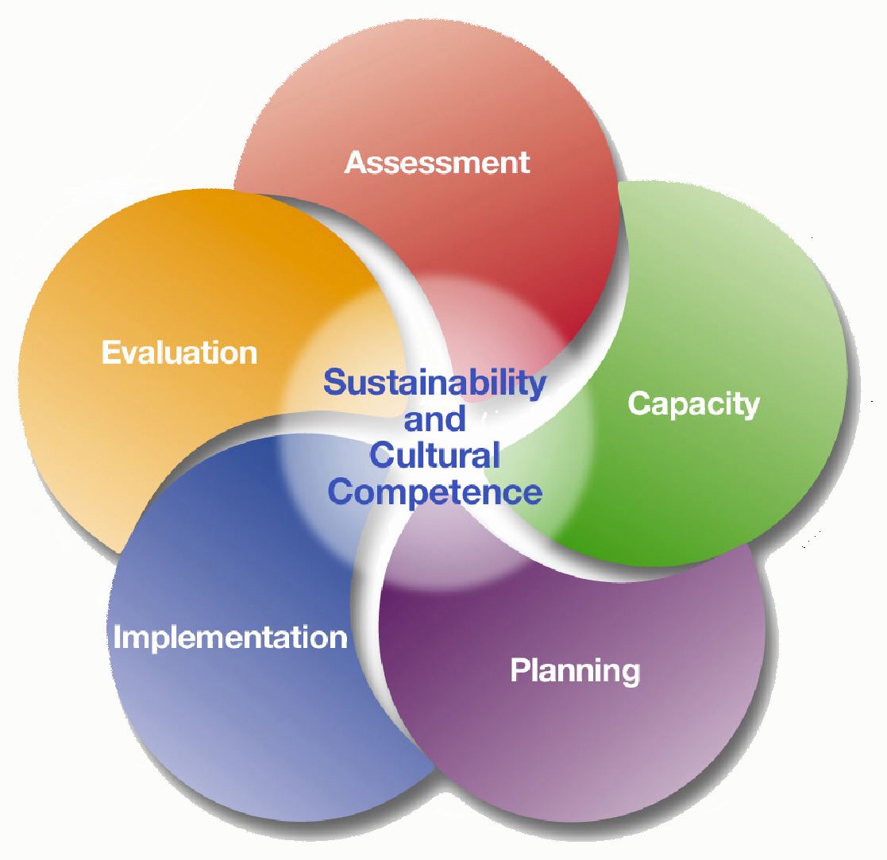

Participants must successfully complete a 4 hour on-line basic prevention training prior to being admitted to the SAPST beginning February 12th. Therefore, the participant must have access to a computer with internet capability. Registrations must include your preferred email address so your registration can be confirmed and so you can receive access to the on-line training, post-test and certificate of completion.

Time is of the essence to register since this announcement is being released one month from the beginning of the training on February 12th and time must be provided from the registration close date of January 31st ***February 6th***.to the training start date of February 12th for the participant to receive their log-in and complete the on-line training.

Training Fee: $25 check, money order or cash. Bring this with you to the training and you will be provided a receipt. Make check payable to PSCBW.

Trainers: This new SAPST training will be facilitated by experienced prevention professionals who have been trained in delivering the new SAPST curriculum.

Attendance and Certificate of Completion: Participants are required to attend all three and one half days of the training. Upon completion, participants will be awarded a certificate. The PSCBW has approved hours from this SAPST to be used toward the application for a Certified Prevention Professional or Associate Prevention Professional credential. Public school personnel are encouraged to obtain clock hours pertaining to this training through the Office of the Superintendent of Public Instruction.

To Register:

1. Send an email titled Yakima SAPST Registration to Alan Zeuge, SAPST Trainer, at [azeuge@spokanecounty.org](mailto:azeuge@spokanecounty.org)
2. In that email provide:
   1. Your name
   2. Your preferred Email address
   3. Your preferred phone number
   4. Your mailing address
3. Alan will acknowledge receipt of your email and let you know of your registration status.
4. Cancellation: If your registration is confirmed and you find that you must cancel please be considerate and let Alan know as soon as possible so others may be offered admission to the training.

For more information about the Prevention Specialist Certification Board of Washington (PSCBW) please visit: [www.pscbw.com](http://www.pscbw.com).

Questions

Please direct all questions about this training to Alan Zeuge, SAPST Site Coordinator:

* Telephone at (509) 477-4508

or

* Email at [azeuge@spokanecounty.org](mailto:azeuge@spokanecounty.org)

This training is supported by funds from the Washington State Department of Social & Health Services – Division of Behavioral Health and Recovery (DBHR)