Request for Applications: Community-based prevention services to prevent and reduce youth substance use.
Estimated Contract Period: July 1, 2016 through June 30, 2017. Amendments extending the period of performance, if any, shall be at the sole discretion of DSHS.
Application Due Date: All proposals must arrive June 10, 2016 by 5:00 P.M. Pacific Standard Time.
Submit Application To: PRItraining@dshs.wa.gov
Informational Webinar: May 27, 2016 11:00 A.M. – 12:00 P.M. Pacific Standard Time.
Register: https://attendee.gotowebinar.com/register/1728706431783299588
Questions: Questions may be submitted to PRItraining@dshs.wa.gov – Each Friday an updated list of Questions and Answers will be posted here: www.theathenaforum.org/I502PreventionPlanImplementation

Application: Request for Applications instructions and related forms can be downloaded at The Athena Forum at www.theathenaforum.org/I502PreventionPlanImplementation

Eligible applicants include community-based organizations and public agencies with youth and family-serving capacity. DSHS/DBHR is interested in applications for proposals from service entities that demonstrate excellence in service delivery to high-need communities, communities of color, veterans and military families, persons with disabilities, and members of LGBTQI2-S communities.

Definitions

“Action Plan” means DBHR’s required template for all applicants to demonstrate an implementation plan during a fiscal term, must include details about program(s), Target Audience, dates, dosage, leadership, and implementation partners.

“Allowable costs” means costs that are allowable as noted in the cost principles of the federal OMB Circular for which the applicant agency is identified for (i.e., A-122 or A-87 rev).

“Allowable programs” means only the programs or strategies offered as choices in Appendix A.

“Coalition” means a formal arrangement for cooperation and collaboration between groups or sectors of a community. Each group retains its identity, but all agree to work together toward a common goal of building a safe, healthy, and drug-free community.

“Community” means a geographic area within school district boundaries, or a specific neighborhood.

“Community-based organization” or “CBO” means a non-governmental agency or organization that serves youth and their families. A CBO may be, but is not limited to, public or private nonprofit (including a faith-based, church or religious entity).

“Community Prevention and Wellness Initiative” or “CPWI” means the DSHS substance use prevention delivery system that focuses prevention services in high-need communities in Washington State as selected by Counties and Contractors and approved by DSHS. More information about CPWI is available at www.dshs.wa.gov/sites/default/files/SESA/publications/documents/22-1464.pdf

“Dedicated Marijuana Account” or “DMA” means revenue generated by the taxation of retail marijuana as a result of the implementation of Initiative 502 (I-502) as authorized in Chapter 4, Laws of 2015 (2nd Special Session); 2E2SHB 2136.

“Evidence-Based Programs” means a program that has been tested in heterogeneous or intended populations. A program that has also had multiple randomized and/or statistically-controlled evaluations, or one large multiple-site randomized and/or statistically-controlled evaluation, and the weight of the evidence from a systematic review demonstrates sustained improvements in at least one of the desired outcomes, can be implemented with a set of procedures to allow successful replication in Washington. It is cost-beneficial.

“Performance Based Prevention System” or “PBPS” means DBHR’s current data information system or its successor.

“Project Narrative” means the written answers to the questions on Form B: Project Narrative of this RFA.

“Direct program services” means services provided to an individual or group using an in-person program delivery method.

“Environmental strategy services” means efforts to implement an environmental strategy in a community setting. Environmental strategies are designed to make community-level change and not intended to focus on specific individuals.

“Health Disparities” means “a particular type of health difference that is closely linked with social, economic, and/or environmental disadvantage. Health disparities adversely affect groups of people who have systematically experienced greater obstacles to health based on their racial or ethnic group; religion; socioeconomic status; gender; age; mental health; cognitive, sensory, or physical disability; sexual orientation or gender identity; geographic location; or other characteristics historically linked to discrimination or exclusion.” (Healthy People 2020)

“Health Equity” means the “attainment of the highest level of health for all people. Achieving health equity requires valuing everyone equally with focused and ongoing societal efforts to address avoidable inequalities, historical and contemporary injustices, and the elimination of health and health care disparities.” (Healthy People 2020)

“Promising Programs” means a program that is based on statistical analyses or a well-established theory of change, shows potential for meeting the “evidence-based” or “research-based” criteria, and could include the use of a program that is evidence-based for outcomes other than the alternative use.

“Ongoing Cycle” means program delivery that is implemented based on an approved plan by DBHR. Ongoing Cycle provides consistent, reliable services that community-based organizations can and other community partners can refer members of the community to participate in during a funding term.

“Research-Based Programs” means a program that has been tested with a single randomized and/or statistically controlled evaluation, demonstrates sustained desirable outcomes; or where the weight of the evidence from a systematic review supports sustained outcomes as identified in the term “evidence-based,” but does not meet the full criteria for “evidence-based.”

“Target Audience” means the indicated program participant a service is designed for based on the program design. A community may determine target audience by geography or sub-population to ensure effective program delivery.

“Work Plan” means the requirements of this application that a contractor demonstrates an ability to meet in order to be eligible for funding.

Purpose

The Washington State Department of Social and Health Services, Division of Behavioral Health and Recovery (DSHS/DBHR) intends to award contracts to community-based organizations (CBOs) or public agencies to serve high-need communities in Washington State to provide quality and culturally competent replications of evidence-based, research-based and promising substance use prevention programs in accordance with RCW 69.50.545. Priority scoring will be given to CBOs serving high-need communities. Organizations are encouraged to partner with Community Prevention and Wellness Initiative (CPWI) Community Coalitions or other existing community coalitions when possible.
DBHR intends to grant up to $20,000 per proposal that will serve a single community and/or up to $100,000 for proposal(s) that serve multiple communities. In accordance with DMA requirements, overall funding opportunity is weighted to fund at least 85% Evidence-based Programs/Research-based programs (EBP/RBP) and up to 15% promising programs. DBHR reserves the right to negotiate with applicants for project scope and funding amounts. Special consideration during selection will include community geographic location(s) to provide for project distribution statewide.
DBHR intends to increase capacity to implement direct and environmental substance use prevention services in communities.

Scope of Work

The work of successful applicants will be in accordance with RCW 69.50.545 and shall include but not be limited to the following:

Implement approved Work Plan, submitted in Project Narrative section of application. Work Plan shall include Approved Program(s) from the (Youth Substance Use/Misuse/Abuse Prevention Programs, Practices & Strategies list) on Appendix A.

Applicant shall select one of the following proposal options ((a), (b), or (c)):

Only Evidence-based (EB) or Research-based (RB) services are proposed.

Only Promising Program services are proposed.

Combination of EB/RB and Promising program services proposed. No less than 85% of the proposed budget shall support programs that are either Evidence-based or Research-based from the provided list in this RFA. No more than 15% of funding shall support Promising Programs from the provided list.

Funds shall be used to support program costs including staff for program planning, training, implementation, reporting and evaluation.

Program(s) will be implemented for Target Audience in which they are designed in an Ongoing Cycle in at least one community. Applications may include a proposal to serve more than one community with demonstrated capacity to do so in Project Narrative section.

Program implementation must be in alignment with the approved Action Plan and Budget submitted with the RFA, including Approved Program(s), dates & timelines, scope, dosage, Target Audience(s), leadership, and responsible parties.

Enter approved implementation Work Plan into designated prevention reporting system (Performance-Based Prevention System (PBPS)) within 30 days of executed contract.

Complete monthly program or strategy services reporting by the 15th of the month following the month of services, including required pre/post-test data.

Participate in monthly learning community meetings.

Participate in monthly check-in phone calls with contract manager or designee.

Application

Request for Applications instructions and related forms can be downloaded at The Athena Forum at www.theathenaforum.org/I502PreventionPlanImplementation

Provide a Project Narrative by answering the questions in Form A. Forms can be downloaded at www.theathenaforum.org/I502PreventionPlanImplementation. If you chose to create a word document, re-state and bold each question in your narrative.

Place all responses and required information under the correct question. Do not direct reviewers to information related to one question in another question. Each question must be answered in its entirety within the numbered question’s answer or supplemental documents. All pertinent information must be included in the Project Narrative for appropriate scoring.
Application Proposal should include the following:

Application Face Page

Project Narrative

Program Action Plan

Program Budget

Contractor Intake Form

Letter of Support from local coalition(s) (if applicable)

Mentoring Program Survey from Mentoring Works Washington (if applicable)

Scoring Criteria

The Project Narrative will be scored according to how well the applicant answers each question using the criteria in Section 7. Each narrative question will be assessed when determining the score for each question. If an applicant cannot answer a specific question, then the reason for this must be explained within the answer to the question. The scoring points and criteria (0-4) in Section 7 will be used for all questions in the Narrative Section.

Proposed Action Plan must align with the proposed Work Plan in the Project Narrative. Action Plan must be complete and detailed. This shall include program/strategy, community/name, Target Audience(s), dates, dosage, leadership, and responsible parties. If the proposed Action Plan and Work Plan do not reconcile, points will be reduced. If an Action Plan is incomplete or includes unallowable proposed costs or programs, the application will be subject to disqualification.

Proposed Budget items must align with the proposed Work Plan in the Project Narrative. Budget must be complete, detailed and all costs proposed must be allowable. A description of how you derived the costs shall be provided in the Budget question (#8) in the Project Narrative. If the proposed Budget and Work Plan do not reconcile, points will be reduced. If Budget is incomplete or includes unallowable proposed costs or programs, the application will be subject to disqualification.

Priority Bonus Points will be awarded for applications that are CBOs; focused in high need communities; and involve coalitions. Priority Bonus Points are application dependent (see section 7).

Scoring for multi-community and single-community applications will be evaluated separately.

If the applicant is a current contractor, performance and implementation of approved Work plan will be included in the consideration for funding.

Applications that do not have a minimum score of at least 25 points will not be considered for funding in the final selection.
Scoring Points and Point Standards:

Total points available are as follows:

Project Description – up to a total of 40 points available

Action Plan – up to 4 points available

Budget – up to 4 points available

Priority Bonus Points - up to 12 points for single-community applications and up to 14 points available for multi-community applications

Points for Project Narrative: Project Description, Action Plan and Budget.
0 points - Unacceptable: The applicant organization does not explicitly address the narrative question. The applicant organization states the question, but does not elaborate on the response. The applicant organization skips or otherwise ignores the question or includes irrelevant information that does not answer the question. As a result, the answer is completely deficient in addressing the narrative question.
1 Point - Marginal: The applicant organization provides minimal details and insufficient descriptions that do not completely answer the narrative question. Limited information is presented or the applicant merely parrots back information included in the RFA. The applicant may answer part of the narrative question but miss a key point or there are major gaps in the information presented.
2 Points - Acceptable: The applicant organization provides a basic response to the narrative question but does not include enough detail or supporting documentation. There are gaps in how the proposal will be implemented.
3 Points - Very Good: The applicant organization provides significant descriptions and relevant details in addressing the narrative question but the response is not fully comprehensive.
4 Points - Excellent: The applicant organization provides significant descriptions and relevant details in addressing the narrative question. The applicant organization demonstrates a sound understanding of the topic and includes pertinent examples.

Priority Bonus Points for Single-Community Applications
4 Priority bonus points shall be given to applications with proposed program services to serve a high-need community from the list provided in Appendix B.
4 Priority bonus points shall be given to applicants that are Community-based Organizations.
Up to 4 Priority bonus points per single-community application shall be given for applications demonstrating collaboration with a community coalition. (Up to 3 points for involvement and collaboration. 1 point shall be given for single-community proposals for submitting at least one letter of support from a local community coalition in the service area.)

Priority Bonus Points for Multiple-Community Applications
Up to 4 Priority bonus points will be awarded for multiple-community applications which include high-need communities, the applicant will receive priority bonus points based on the number of high-need communities included. (0 points for no high-need communities; 1 point for 2-3 high-need communities; 2 points for 4-5 high-need communities; 3 point for 5-6 high-need communities; 4 points for 7 or more high-need communities)
4 Priority bonus points shall be given to applicants that are Community-based Organizations. For multiple-community proposals, the Applicant shall be a Community-based Organization to be awarded the bonus points.
Up to 4 Priority bonus points will be awarded for multiple-community proposals based on demonstrated collaboration with community coalitions in relation to the number of high-need communities. (0 points – no coalitions; up to 1 point for 2-3 coalitions; up to 2 points for 4-5 coalitions; up to 3 point for 5-6 coalitions; up to 4 points for 7 or more coalitions)
Up to 2 Priority bonus points per coalition letter of support will be awarded for multiple-community proposals. (0 points – no letters; up to .5 points for 2-3 letters; up to 1 point for 4-5 letters; up to 1.5 point for 5-6 letters; up to 2 points for 7 or more letters)

Form A: Application Face Page – SAMPLE

(Forms can be downloaded at www.theathenaforum.org/I502PreventionPlanImplementation)

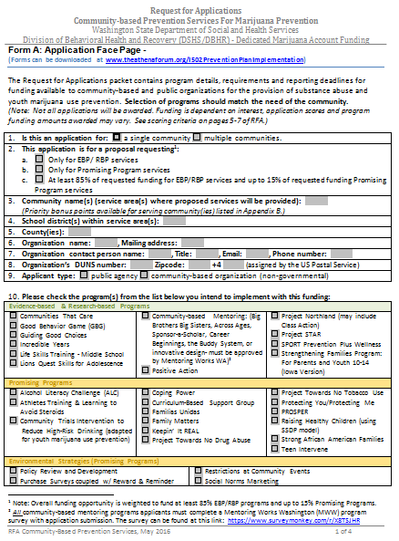
SAMPLE
Form B: Project Narrative - SAMPLE

(Forms can be downloaded at www.theathenaforum.org/I502PreventionPlanImplementation)
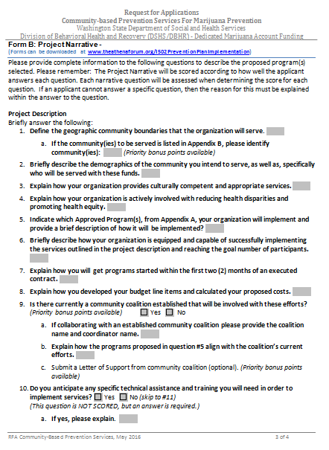
SAMPLE
SAMPLE
Form C: Action Plan - SAMPLE

(Forms can be downloaded at www.theathenaforum.org/I502PreventionPlanImplementation)
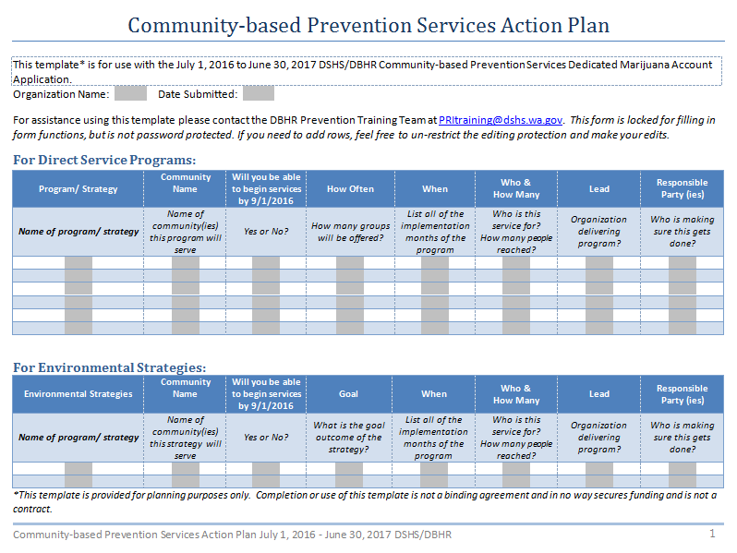
SAMPLE
Form D: Project Budget - SAMPLE

(Forms can be downloaded at www.theathenaforum.org/I502PreventionPlanImplementation)
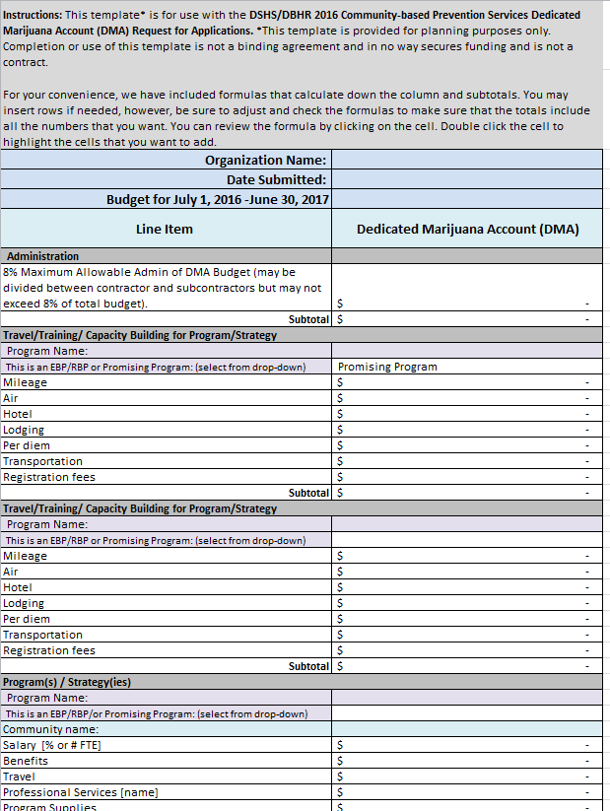
Form E: Contractor Intake - SAMPLE
SAMPLE

(Forms can be downloaded at www.theathenaforum.org/I502PreventionPlanImplementation)

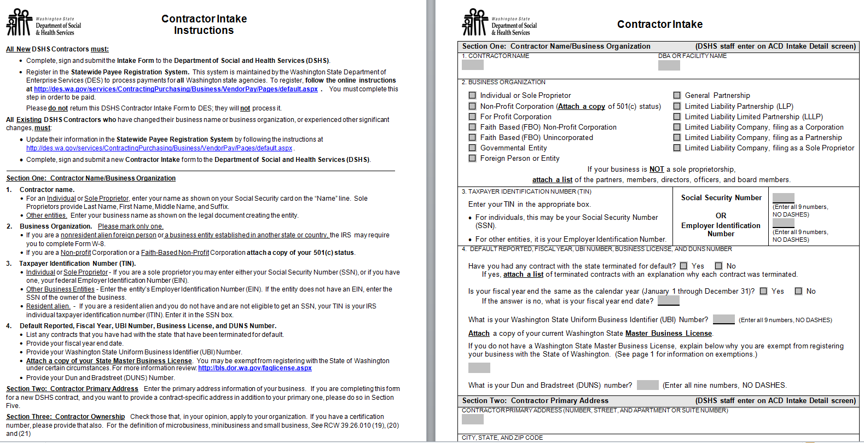
SAMPLE

Appendix A: Prevention Programs and Practices for Youth Marijuana Use Prevention

(for DMA Community-based Prevention Services Grants)
Note: No less than 85% of DMA funds can be used to support Evidence-Based and Research-Based Programs and no more than 15% of DMA funds can be used to support Promising Programs from the list below.

Evidence-Based & Research-Based Programs
- Communities That Care
- Good Behavior Game (GBG)*
- Guiding Good Choices*
- Incredible Years*
- Life Skills Training - Middle School (Botvin Version; Grades 6, 7, and 8)
- Lions Quest Skills for Adolescence*
- Community-based Mentoring* (Across Ages, Big Brothers Big Sisters, The Buddy System, Career Beginnings, Sponsor-a-Scholar, and Mentoring Works Washington.) Locally developed programs may be considered but require DBHR approval and consultation with Mentoring Works Washington.
- Positive Action*
- Project Northland (Class Action may be done as booster)
- Project STAR
- SPORT Prevention Plus Wellness
- Strengthening Families Program: For Parents and Youth 10-14 (Iowa Version)*

Promising Programs
- Alcohol Literacy Challenge (ALC)  - Athletes Training & Learning to Avoid Steroids  - Community Trials Intervention to Reduce High-Risk Drinking (adapted for youth marijuana use prevention)  - Coping Power  - Curriculum-Based Support Group (CBSG) Program*  - Familias Unidas  - Family Matters  - Keepin’ It REAL | - Project Toward No Drug Abuse  - Project Towards No Tobacco Use  - PROSPER  - Protecting You/Protecting Me  - Raising Healthy Children (using SSDP model)  - Strong African American Families  - Teen Intervene

Environmental Strategies (Promising)
- Policy Review and Development
- Purchase Surveys coupled with Reward and Reminder
- Restrictions at Community Events
- Social Norms Marketing

Notes:
- (*)These programs are also programs with Mental Health Promotion areas of interest and outcomes as found on NREPP.
- List is updated annually based on most up-to-date research information.
- Keepin’ It REAL (KIR) is designated as a “Promising Program” for all newly implemented programs. Successful CBO applicants whom implemented in SFY 2016 may continue to count KIR as a “Research-based Program” for this funding opportunity.
Notes and Resources used in determining this program list
DSHS/DBHR would like to thank the following individuals and groups for their consultation, program search and review contribution efforts, and overall generous support in developing this list.
- University of Washington’s Social Development Research Group
Kevin Haggerty, Ph.D.; Rico Catalano, Ph.D.; Daniel Gangon, graduate student;
- Washington State University
Laura Griner Hill, Ph.D.; Brittany Rhoades Cooper, Ph.D.; Angie Funaiole, graduate student; and Eleanor Dizon, graduate student;
- Washington State Institute for Public Policy
Steve Aos; Annie Pennuchi; Adam Darnell, Ph.D.; Marna Miller, Ph.D.; and Matt Lemon;
- Pacific Institute for Research and Evaluation
Sean Hanley, Ph.D.; and
- Washington State Prevention Research Subcommittee.
- A special thank you to Grace Hong, Ph.D., and Lyz Speaker, MS, for their foundational literature review and analysis.

Washington State Institute for Public Policy (WSIPP), Preventing Youth Substance Use: A Review of Thirteen Programs, September 2014 report http://www.wsipp.wa.gov/ReportFile/1562/Wsipp_Preventing-Youth-Substance-Use-A-Review-of-Thirteen-Programs_Report.pdf
Washington State Institute for Public Policy (WSIPP), Preventing and Treating Youth Marijuana Use An Updated Review of the Evidence Report, October 2014 report http://www.wsipp.wa.gov/ReportFile/1571/Wsipp_Preventing-and-Treating-Youth-Marijuana-Use-An-Updated-Review-of-the-Evidence_Report.pdf.
Washington State Institute for Public Policy (WSIPP),Updated Inventory of Evidence-based, Research-based, and Promising Practices For Prevention and Intervention Services for Children and Juveniles in the Child Welfare, Juvenile Justice, and Mental Health Systems, July 2015 report http://www.wsipp.wa.gov/ReportFile/1609/Wsipp_Updated-Inventory-of-Evidence-based-Research-based-and-Promising-Practices-For-Prevention-and-Intervention-Services-for-Children-and-Juveniles-in-the-Child-Welfare-Juvenile-Justice-and-Mental-Health-Systems_Report.pdf
Environmental Strategy Implementation Fidelity Assessment Guidelines, 2013, http://theathenaforum.org/sites/default/files/Environmental%20Strategy%20Fidelity%20Assessment%20Guide%20(with%20footnotes).pdf

Appendix B: Priority High-Need Community List for Prevention Services

County | School District Name
Benton | Finley
Chelan | Manson
Chelan | Entiat
Clark | Vancouver: Fort Vancouver H.S.
Douglas | Eastmont
Grant | Quincy
Grant | Grand Coulee Dam
Grays Harbor | Aberdeen
Grays Harbor | Elma
Jefferson | Port Townsend
Lewis | White Pass
Lewis | Centralia
Lewis | Pe Ell
Mason | North Mason
Mason | Hood Canal
Pacific | Willapa Valley
Pierce | Tacoma: Lincoln H.S.
Pierce | Bethel
Pierce | Tacoma
Pierce | Eatonville
San Juan | Orcas Island
Skagit | Sedro-Woolley
Snohomish | Granite Falls
Spokane | Spokane: Rogers H.S.
Spokane | Riverside
Spokane | West Valley (Spokane)
Spokane | Deer Park
Stevens | Wellpinit
Thurston | Yelm
Walla Walla | Prescott
Yakima | Mabton
Yakima | Granger
Yakima | Grandview
Yakima | Toppenish

Appendix C: List of Current CPWI Communities

Contact information for each community coalition is available online at www.theathenaforum.org/cpwi_coalitions The list below use school district and high school attendance areas are used a proxy for community.

County | CPWI Community
Adams | Othello
Asotin | Clarkston
Benton | Prosser
Chelan | Wenatchee
Clallam | Forks  Joyce*
Clark | Discovery  Washougal
Columbia | Dayton
Cowlitz | Castle Rock
Douglas | Waterville
Ferry | Republic
Franklin | Pasco S.D.
Garfield | Pomeroy
Grant | Mattawa*  Moses Lake
Grays Harbor | Hoquiam
Island | Oak Harbor
Jefferson | Chimacum
King | Central Seattle  South East Seattle  Vashon Island  White Center/ Highline  Chief Sealth*
Kitsap | Bremerton  North Kitsap
Kittitas | Cle Elum/Roslyn
Klickitat | Klickitat/Lyle
Lewis | Morton
County | CPWI Community
Lincoln | Reardan
Mason | Shelton
Okanogan | Omak
Pacific | Long Beach
Pend Oreille | Cusick
Pierce | Clover Park  Orting  Tacoma/Franklin Pierce  Tacoma (Foss High School Area)*
San Juan | San Juan
Skagit | Concrete
Skamania | Stevenson
Snohomish | Darrington  Marysville  Monroe
Spokane | West Central  East Valley
Stevens | Springdale
Thurston | Rainer  Tenino
Wahkiakum | Wahkiakum
Walla Walla | Walla Walla
Whatcom | Bellingham  Ferndale
Whitman | Tekoa
Yakima | Sunnyside  White Swan  Wapato*  Yakima SD*

Communities with an (*) are new CPWI communities. Please email PRItraining@dshs.wa.gov for a contact person in these communities, if needed.

RCW 69.50.545 text can be found at http://app.leg.wa.gov/RCW/default.aspx?cite=69.50.540
DBHR is not excluding any CBO from applying. Please submit your application for consideration even if your community is not on the prioritized list.
Note: Overall funding opportunity is weighted to fund at least 85% EBP/RBP programs and up to 15% promising programs.
DBHR is not excluding any CBO from applying. Please submit your application for consideration even if your community is not on the prioritized list.
All Community-based Mentoring programs applicants must complete a Mentoring Works WA program survey with application submission. www.surveymonkey.com/r/X8TSJHR

