View/Print your transcript

TLC Navigation
Instructions: Find the instruction number on the corresponding picture to find the area on the screen to click.

Click Transcript, a new window will open.
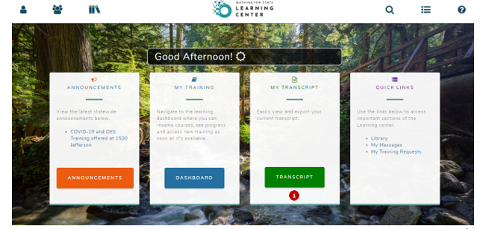
^
- Click the Drop-down ( ) to determine the date range you want to print or view.
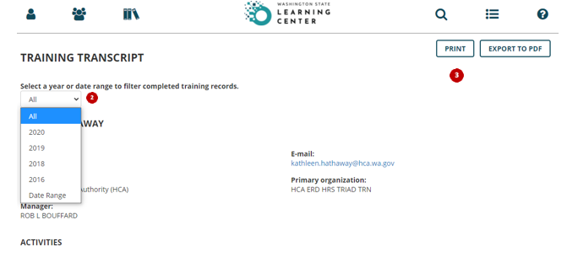

Click on Print or Export to PDF

Tip:
- Sorting by all will not allow you to view all of your classes on your screen
- You will need to select a Year to view on screen or Print/Export to PDF in order to view all classes

Glossary of Terms
TLC | The HCA Learning Center (TLC)
Transcript | A record of trainings that you have completed as a State of Washington employee or contractor
Drop-down Menus | When you click the drop-down symbol, it displays a menu of options to choose from  ^

Contact your TLC Division Coordinator at

