Hosting a Virtual STAND Event

If you’d like to apply for a STAND mini-grant, but aren’t sure what your group would do, here are several suggestions on impactful virtual events you could consider. You can also come up with your own ideas to offer a one-time educational or advocacy activity to raise awareness about tobacco, vaping, and nicotine. You’ll also find a few suggestions on how you could spend your grant money.

- Students deliver a short, virtual tobacco and vaping presentation to health classes to help their peers understand the dangers of tobacco use. This doesn’t have to be a PowerPoint presentation. Play Bingo with tobacco facts or another game and offer prizes to the winner(s).

- Youth lead a virtual class discussion during health or life skills classes on how to successfully say no to tobacco products at sports practices, at parties, and other challenging environments.

- Teens create a social media opportunity that allows other youth to post about how they have been offered tobacco products and how they have successfully said no. Offer prizes for the posts most liked by others.
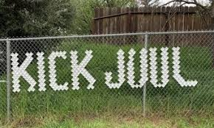

- Youth, working in shifts to allow proper social distancing, use cups to build an anti-tobacco message in a fence around the school or other area frequented by youth after receiving any required permission(s).

- Youth, working in shifts to allow proper social distancing, pick up tobacco trash in a local area frequented by youth such as a local park, convenience store, or shopping area and then post their results on social media or through their school’s communication channels.

- Youth coordinate time with a local legislator to provide education about the dangers of youth tobacco use and how to protect youth from the products.

Ways to Spend your virtual funds:
- Buy t-shirts or hoodies for your youth team.
- Offer prizes during virtual events to build participation.
- Purchase materials to host a safe, socially distanced in-person event.

